# AMAZON ELASTIC COMPUTE CLOUD (EC2)

**Amazon Elastic Block Store (EBS)** is a high-performance block storage service used with Amazon EC2 instances, providing persistent storage that can be attached and detached, and used for **data storage and transfer**, including **creating snapshots** for **backups and disaster recovery.**

To connect an **EBS (Elastic Block Store)** volume to an **EC2 instance** **within the same AWS availability zone**, follow these steps:

**To Launch EC2 Instance**

Compute 🡪 EC2 🡪 Instance 🡪 Launch Instance 🡪 Name 🡪AMS’S

**[ Microsoft windows server 2025 base ]** 🡪 Instance **type:** t3.medium (2 CPU &

4GB RAM) 🡪 Key pair 🡪 Name 🡪 **RSA**  🡪  **.Pem (open ssh )** 🡪 Save

**Step1:** In the **AWS Services** search bar, type **EC2** and click on **EC2** to open the **EC2 Dashboard**

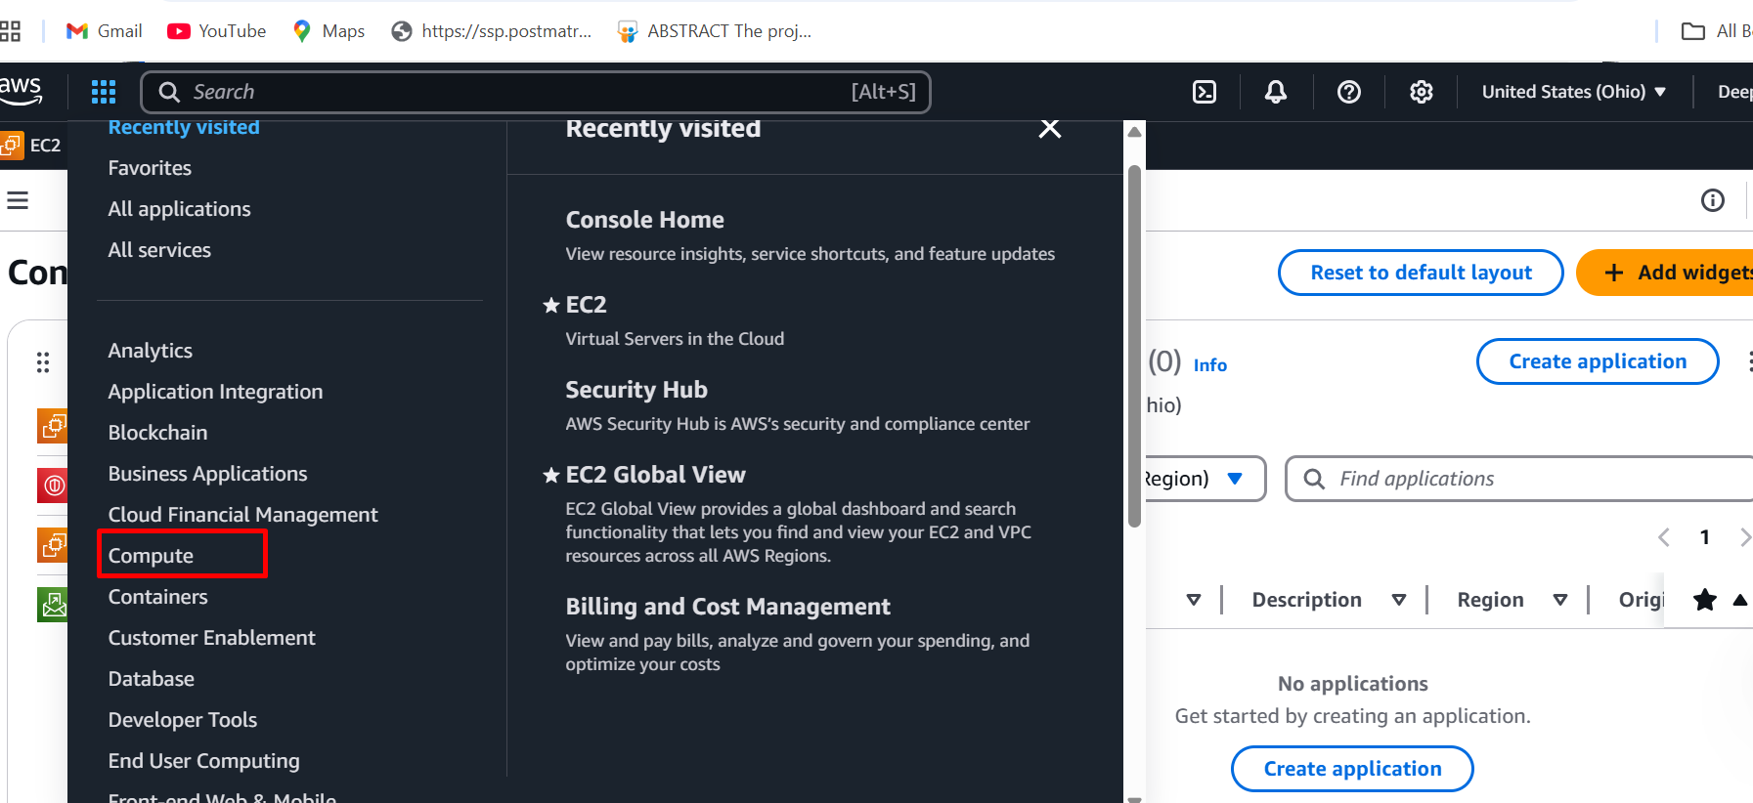

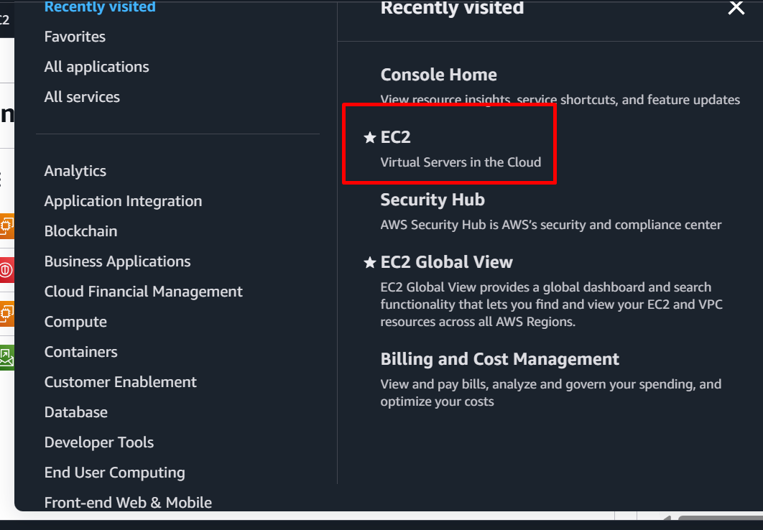

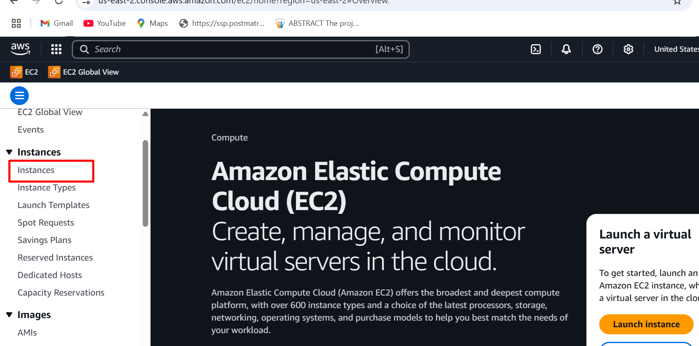

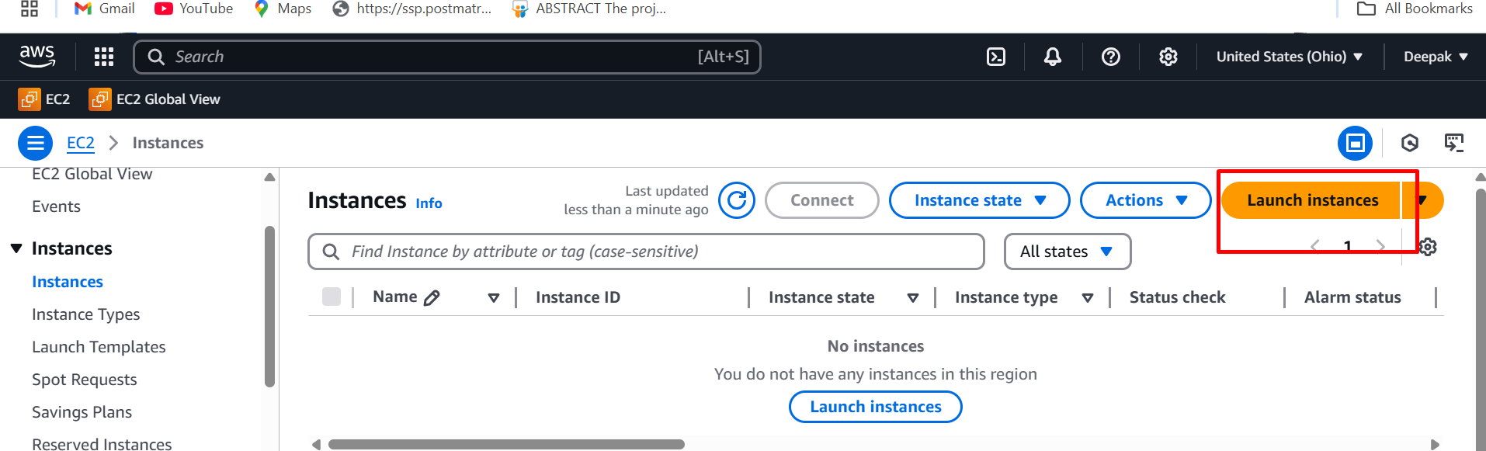

**Step2:** Enter the instance **name** window-server-1

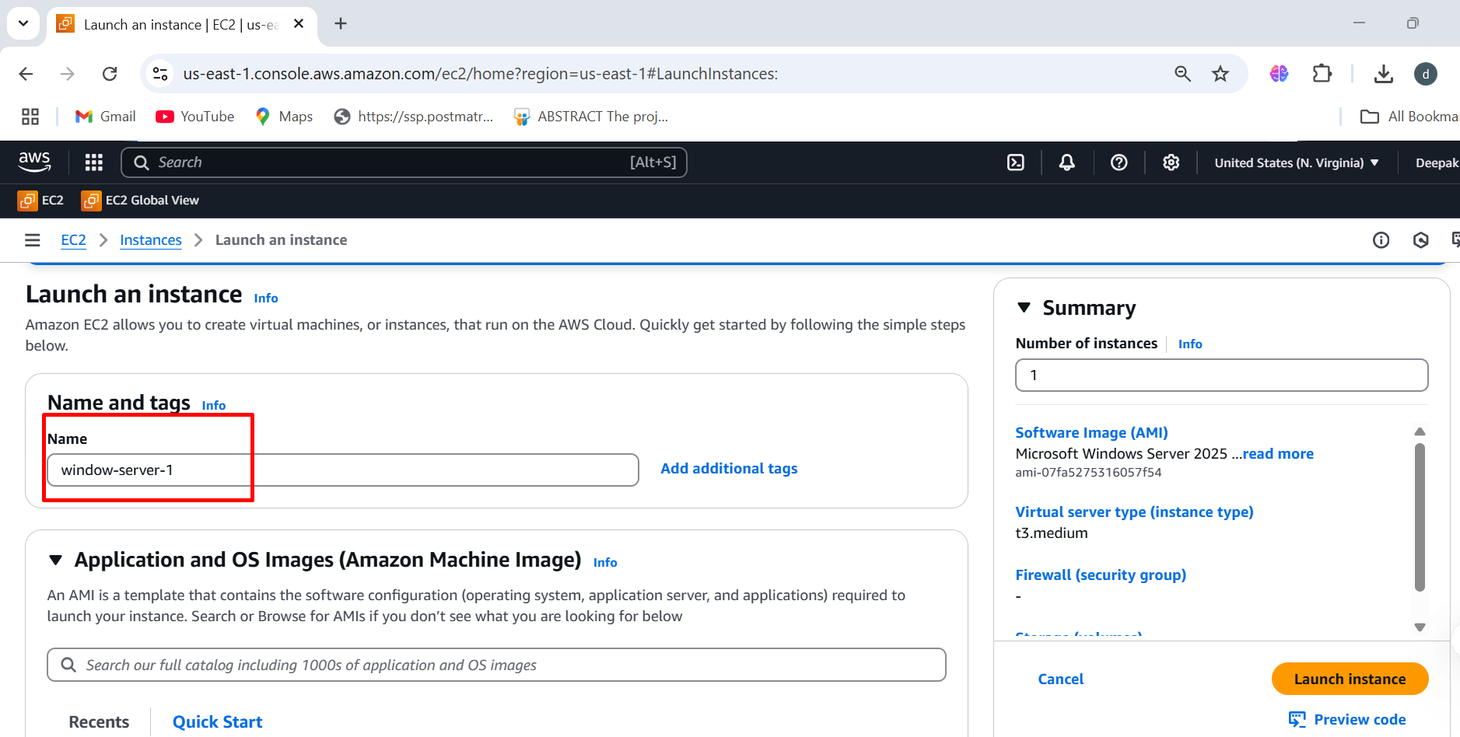

**Step3:** Choose the Amazon machine image (**windows server 2025 base**)

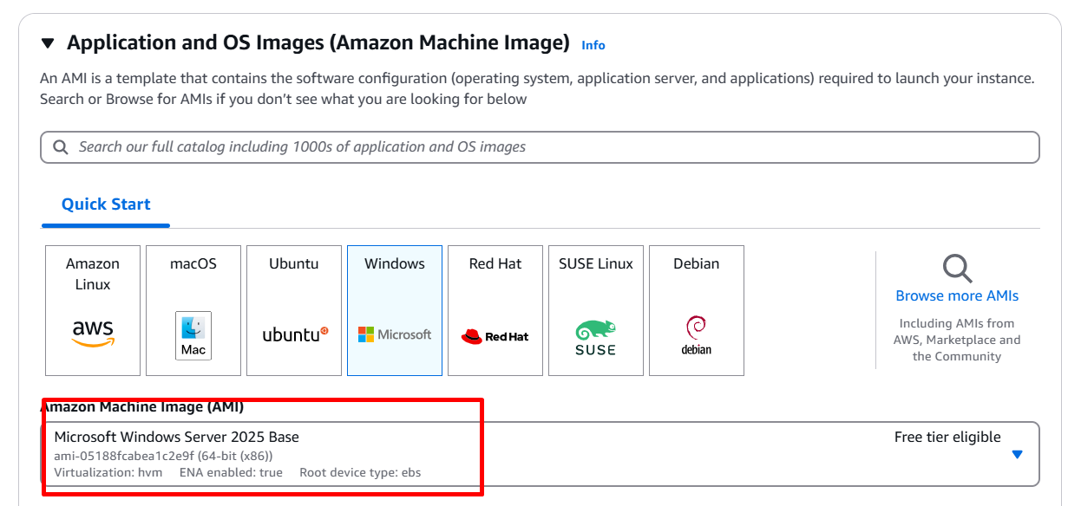

**Step4:** Select the instance type (**t3.medium 2cpu, 4GB RAM)**

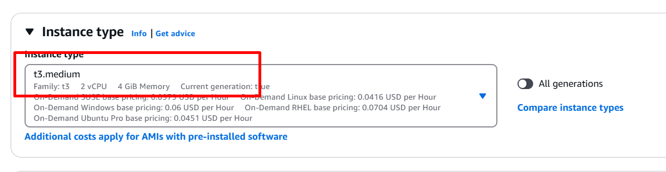

**Step5:** Create **key pair** to connect to the instance

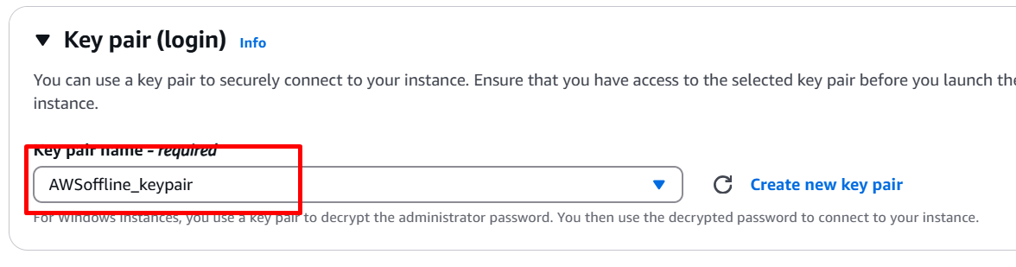

**Step6:** Under the network settings edit and add subnet (us -east-1a) 🡪 add availability zone 🡪 select existing security group 🡪 windows-ssh-security

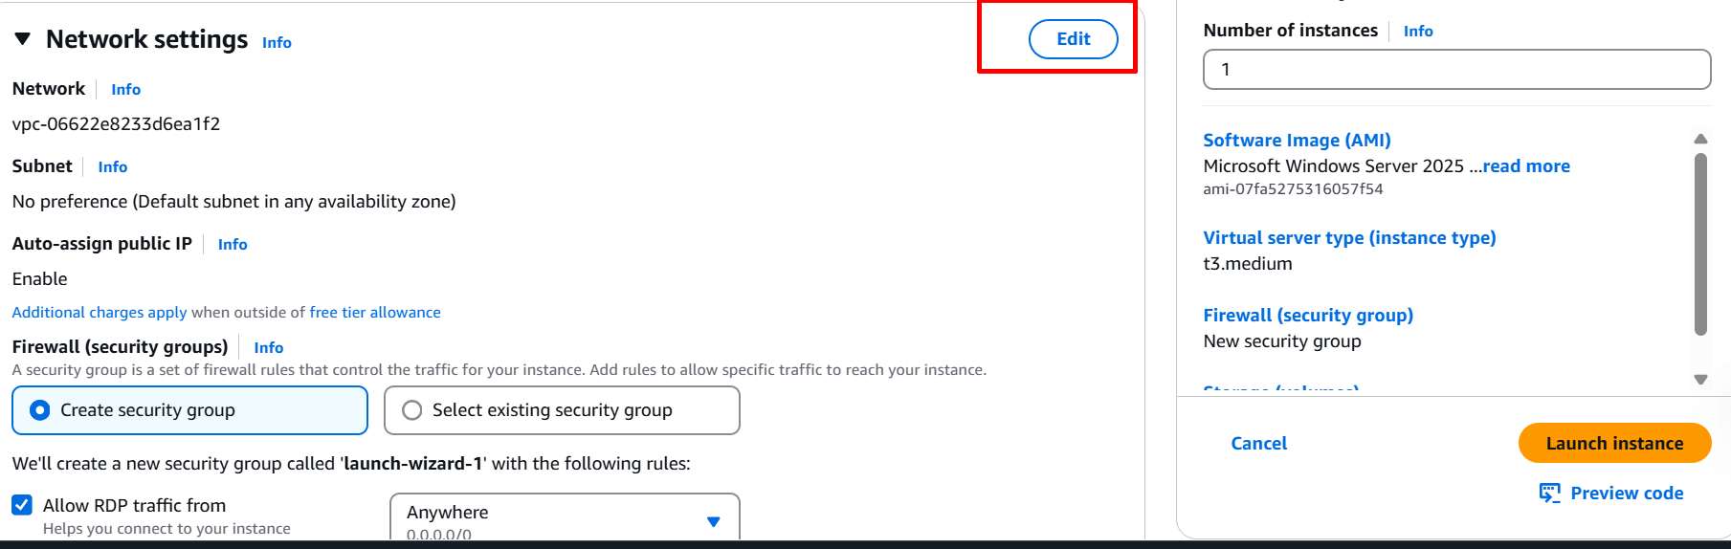

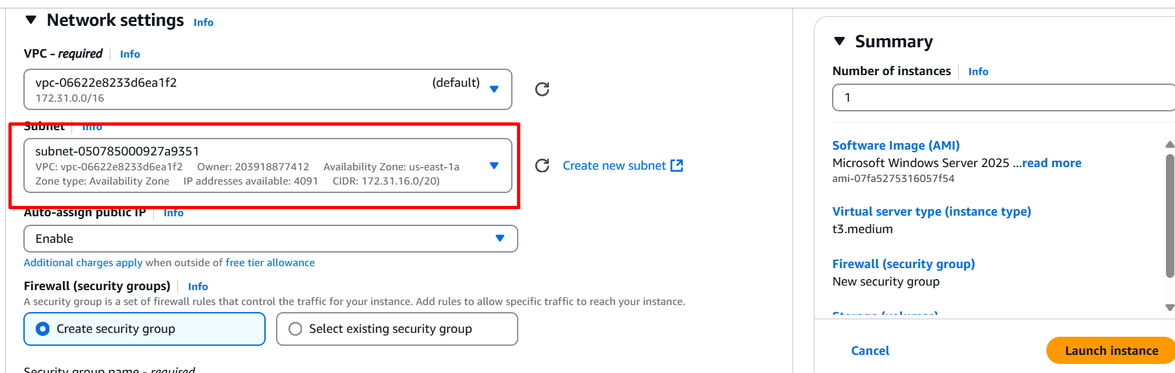

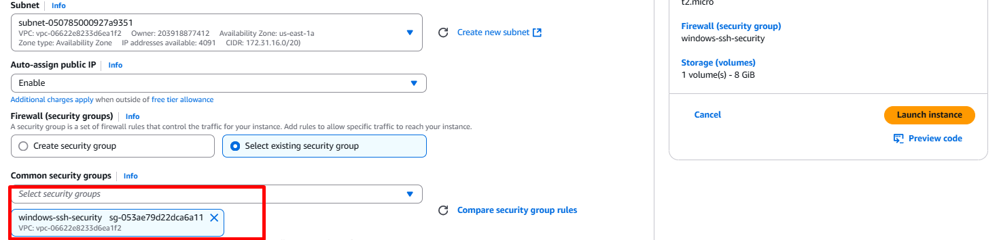

**Step7:** Select the **storage 30GB** 🡪 launch instance

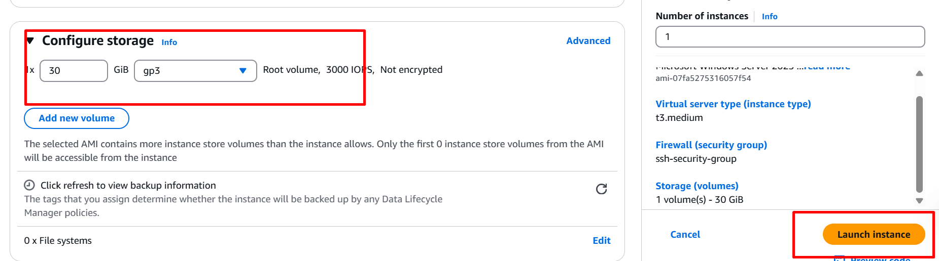

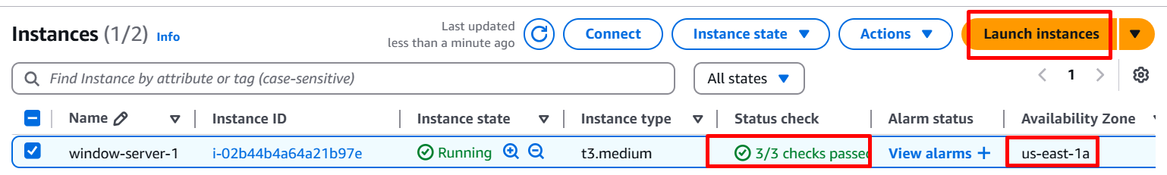

**Creating The Volume**

Navigating to the EC2 Dashboard, follow these steps to create an EBS Volume:

Volume 🡪 Create Volume 🡪 sizeof volume (50GB) 🡪 Availability zone

(us-east-1a) 🡪 Create volume

**Step1:** In the left navigation panel, scroll down to **Elastic Block Store (EBS)**. 🡪 click on volumes

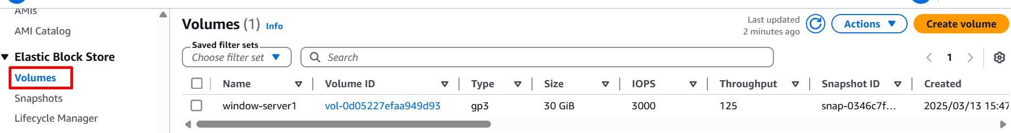

**Step2:** Create a New EBS Volume 🡪 Create a **New EBS Volume** 🡪 A **Create Volume form will appear.**

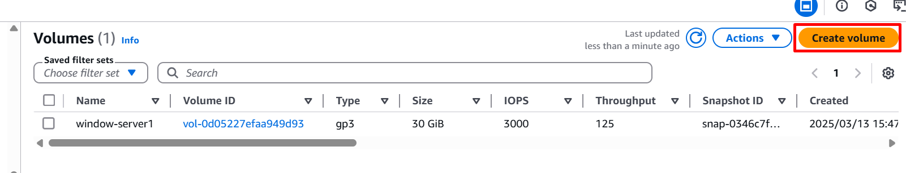

**Step3:** Configure the Volume 🡪 Enter **50 GiB as the storage capacity** 🡪 Select **us-east-1a** (Make sure it matches your EC2 instance's AZ) 🡪

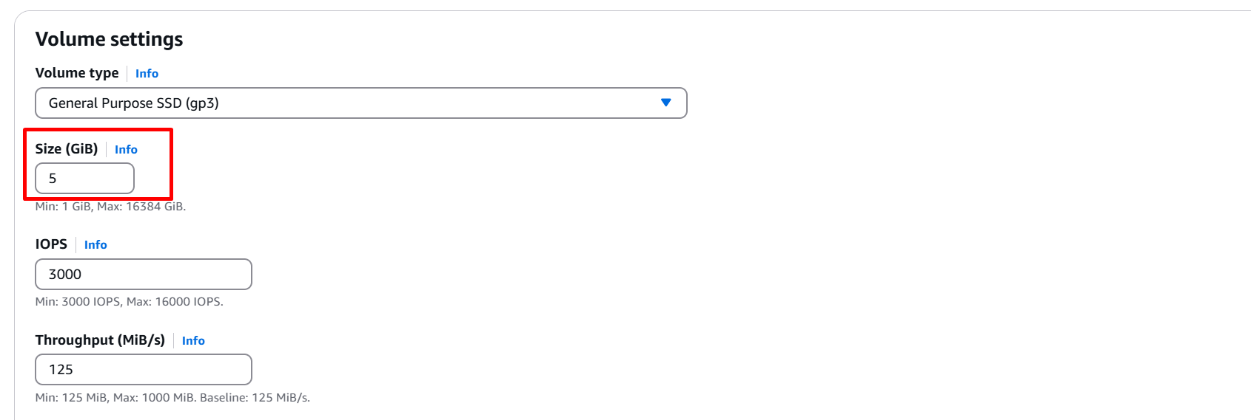

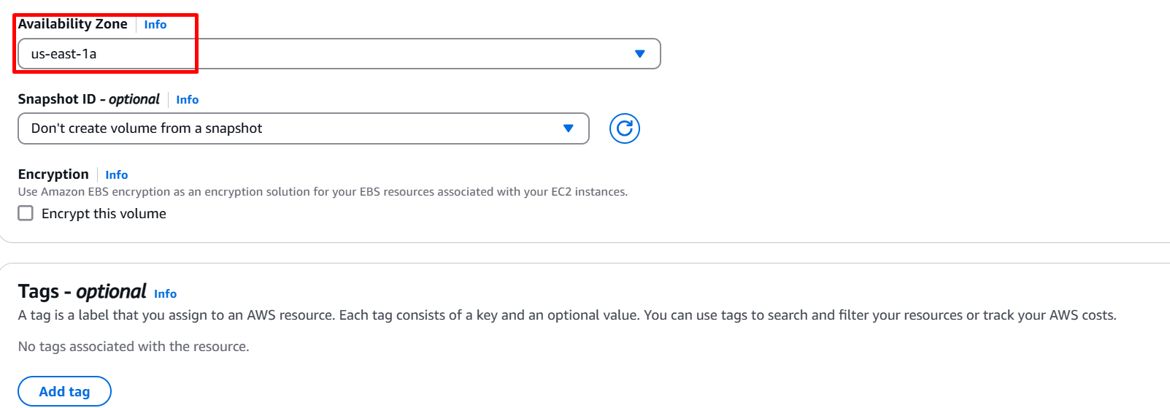

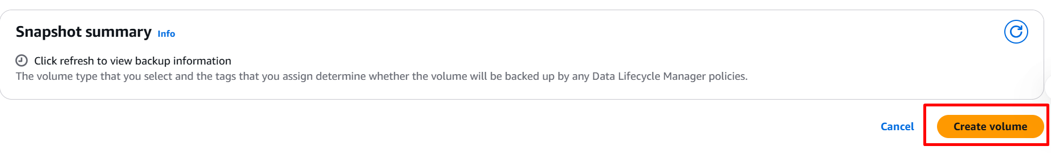

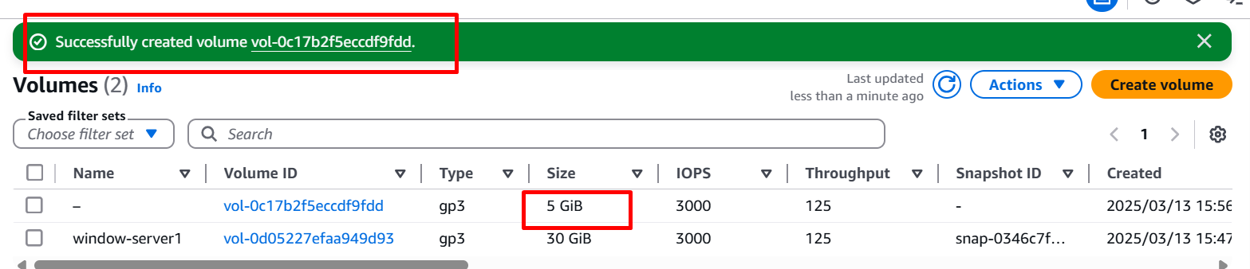

**Attaching Volume**

After creating the **EBS Volume**, the next step is to **attach it to an EC2 instance** in the same **Availability Zone (AZ)**.

Select volume 🡪  **Actions** 🡪 Attach volume 🡪 Select the instance 🡪

Device name 🡪 **xvd[f-p]** 🡪 Attach

**Step1: Attach the Volume to an EC2 Instance**

1. Select the EBS Volume 🡪 Click on the checkbox next to your volume.

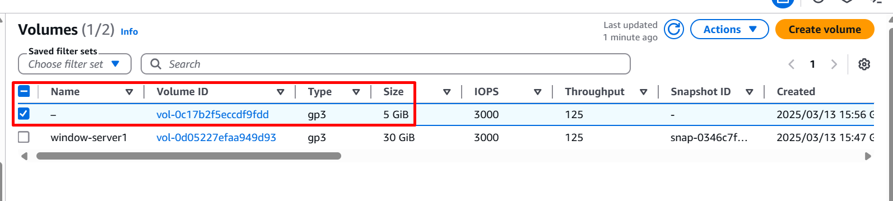

1. Click on Actions 🡪 At the top-right, click **Actions**  🡪 **Attach Volume.**

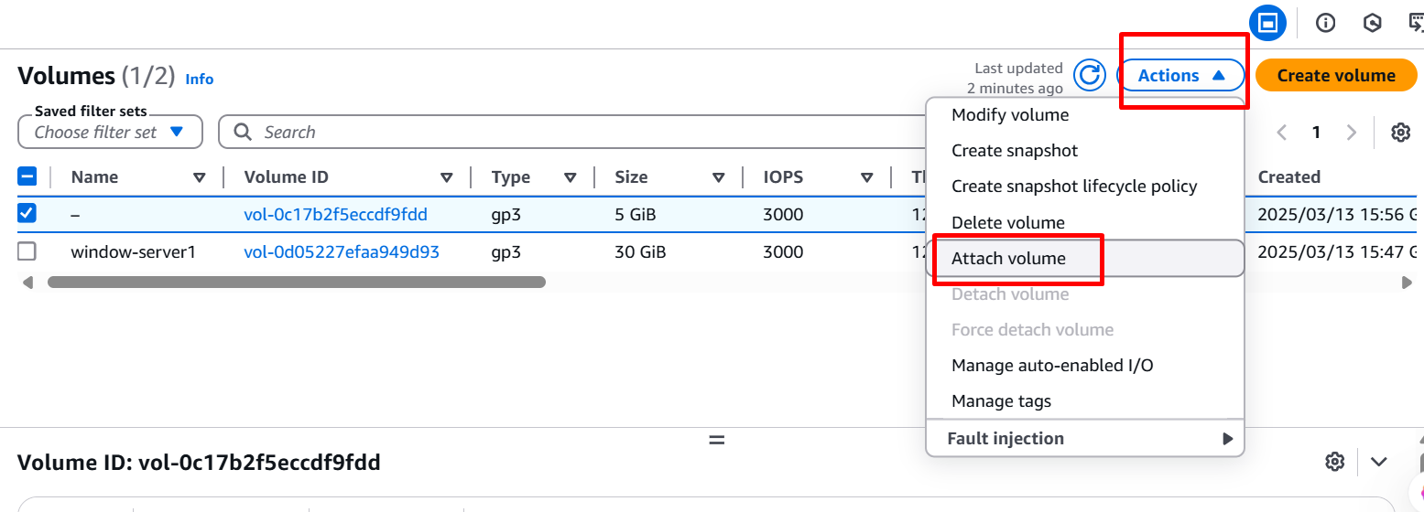

1. Select the EC2 Instance 🡪 In the Attach Volume window 🡪 Click the dropdown under Instance 🡪 Select the EC2 instance that is in the same Availability Zone (us-east-1a).

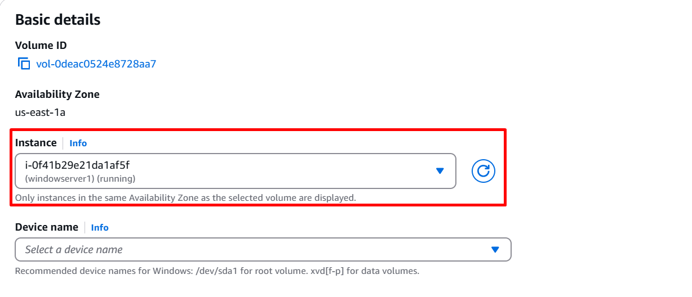

1. Specify Device Name 🡪 Enter the device name in Device Name field 🡪 Use xvd[f-p] (e.g., /dev/xvdf, /dev/xvdg, etc.) 🡪 AWS automatically suggests a name like /dev/xvdf, but you can modify it 🡪 Click on Attach Volume

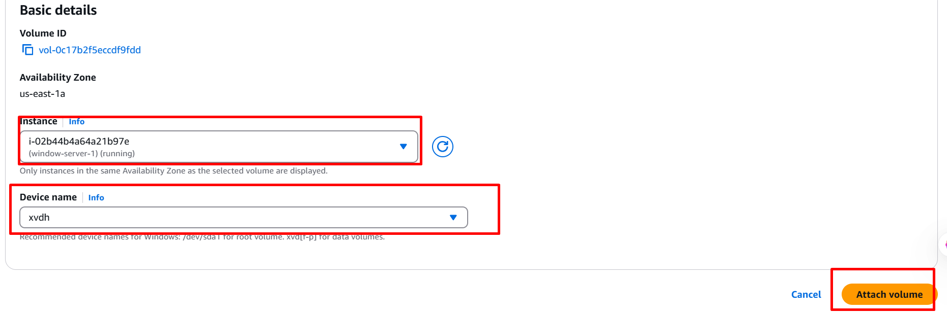

**Connecting to a Windows EC2 Instance and Using the Attached EBS Volume**

**Step1:** In the left navigation panel, click on Instances 🡪 Select your Windows EC2 instance 🡪 Click Connect (top right).

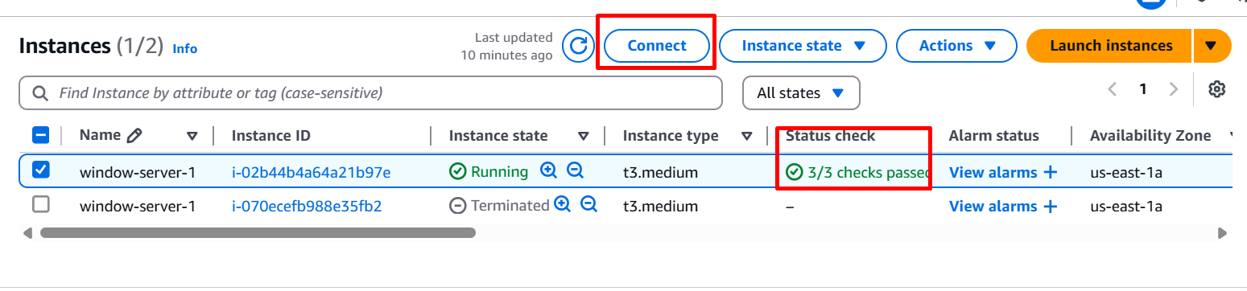

**Step2:** Under the RDP Client tab 🡪 Click Download Remote Desktop File 🡪 Click Get Password (if not already retrieved) 🡪 Upload your private key (.pem) file and click Decrypt Password 🡪 Copy the Administrator username and decrypted password.

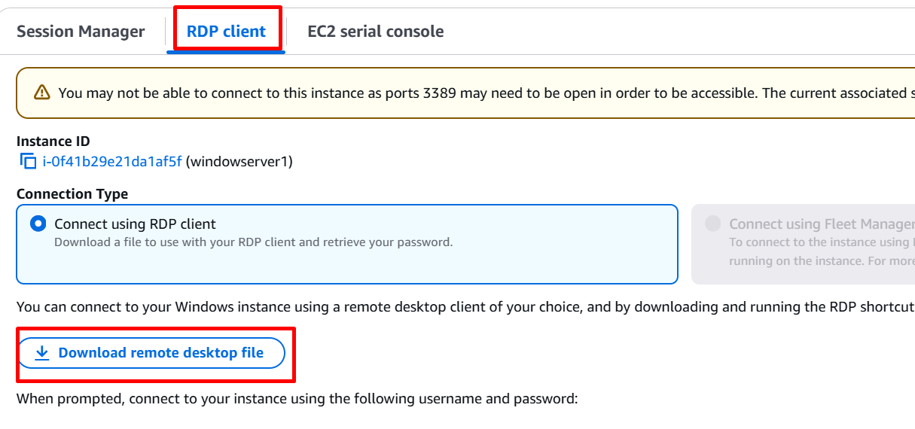

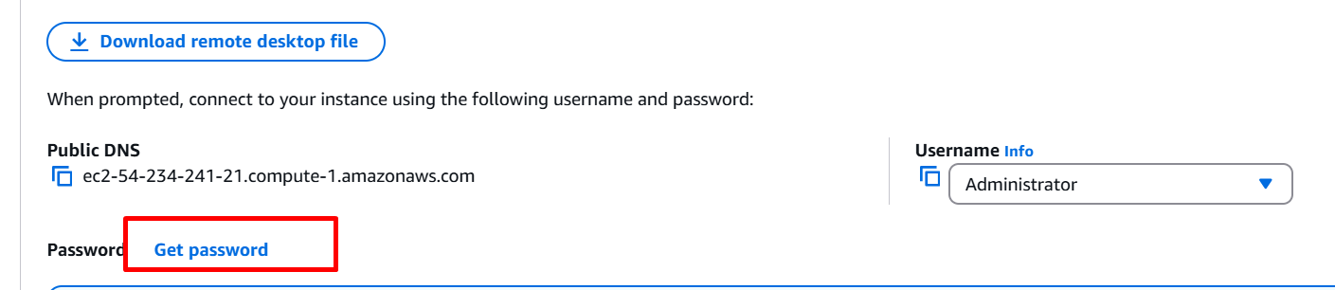

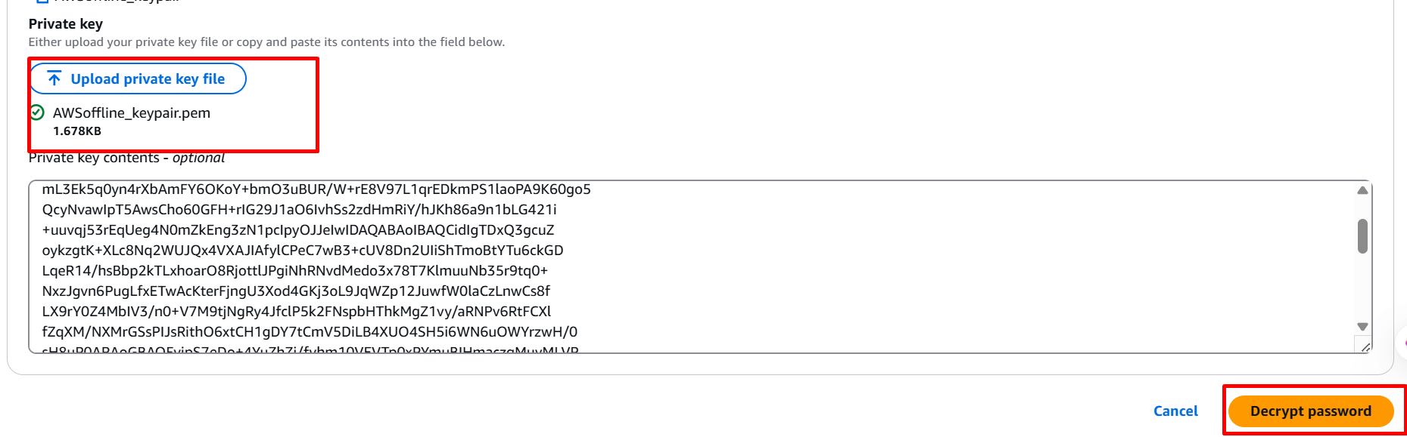

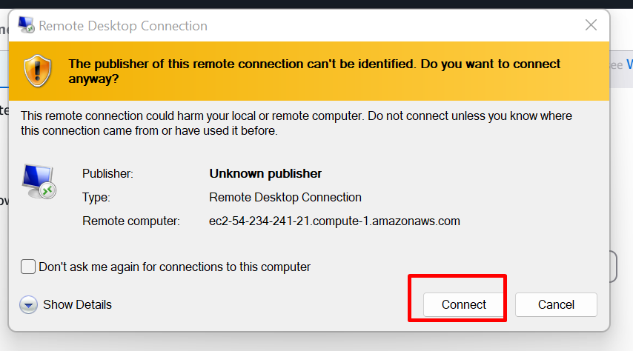

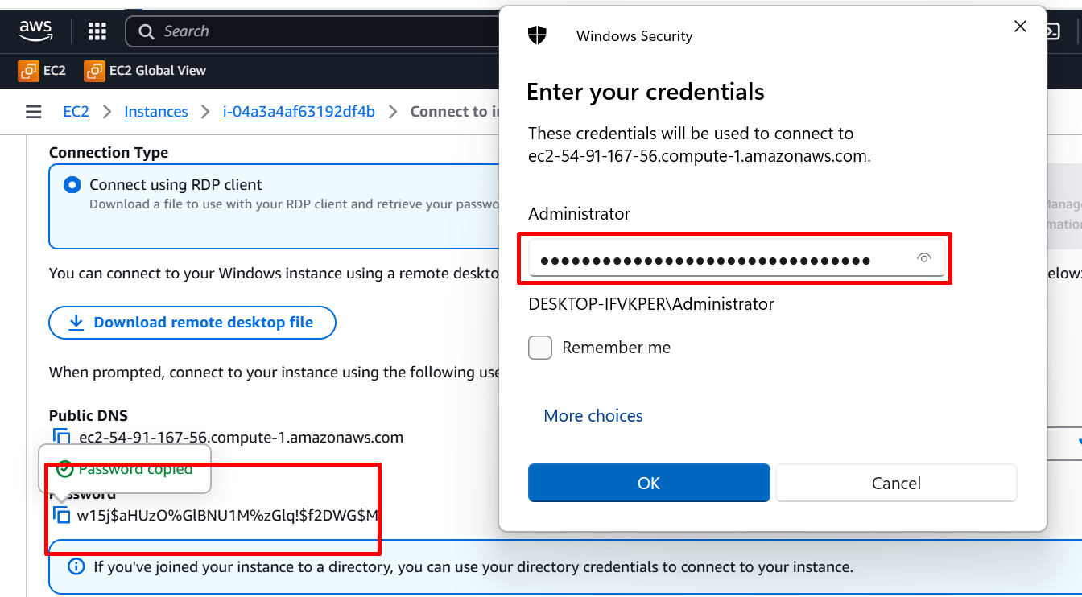

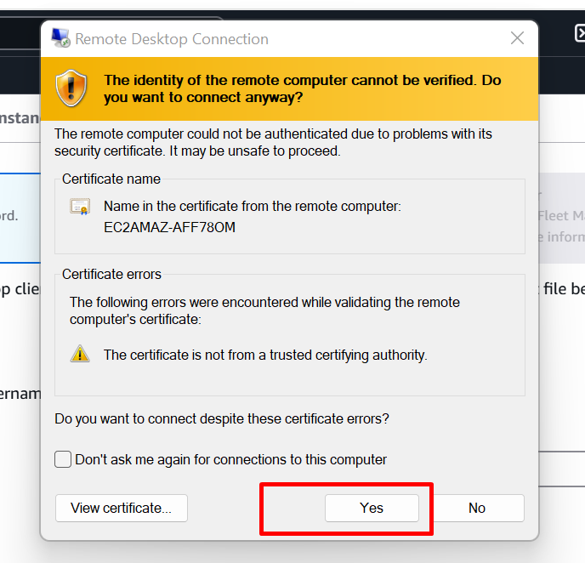

**CONNECT TO VIRTUAL WINDOW SERVERS**

**Step1:** Open server manager in windows

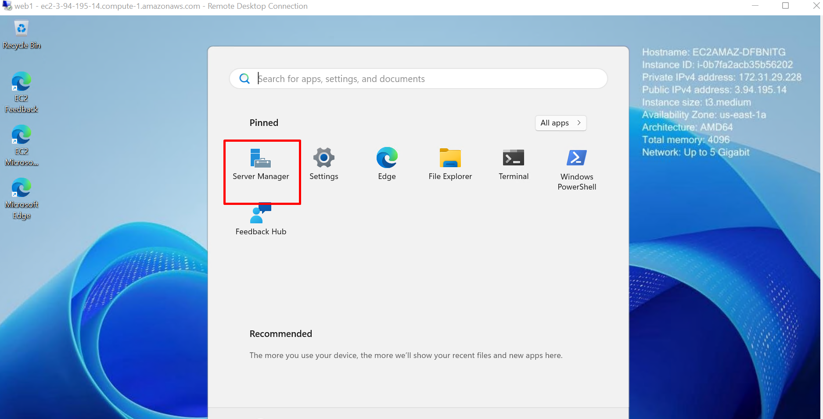

**Step2:** Click on **files & storage services**

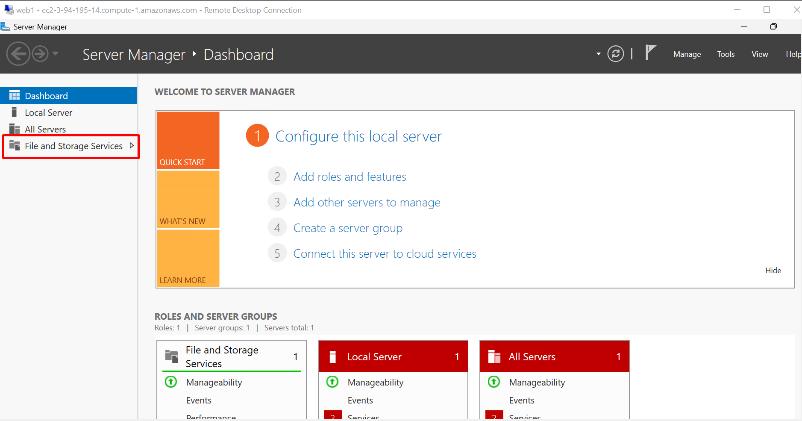

**Step4:** select disk and initialize the partition

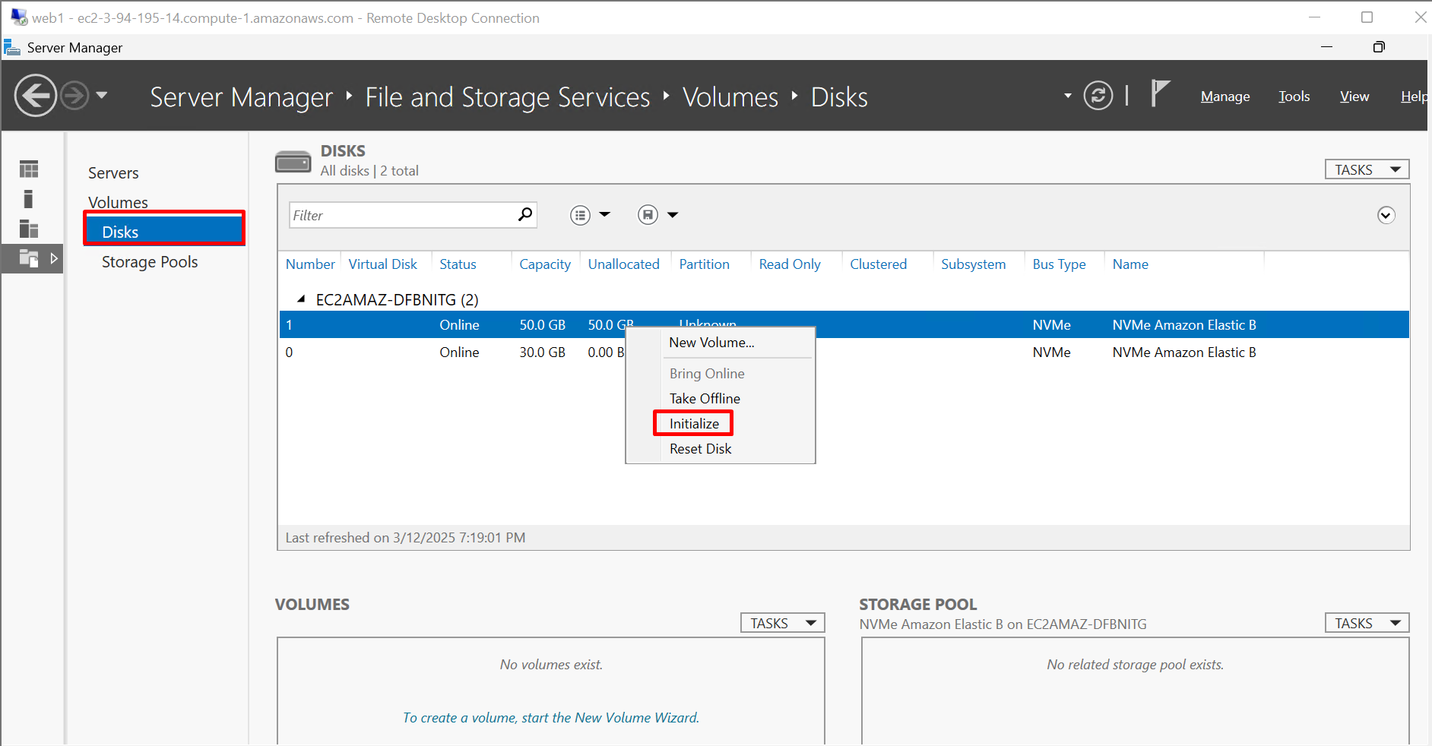

**Step5:** Create a new volume

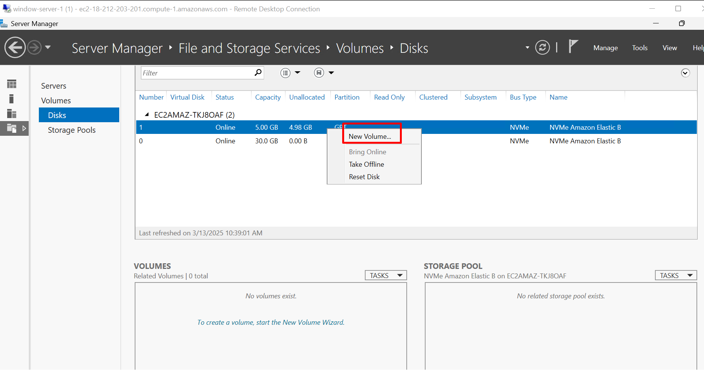

**Step6:** Select the server and disk

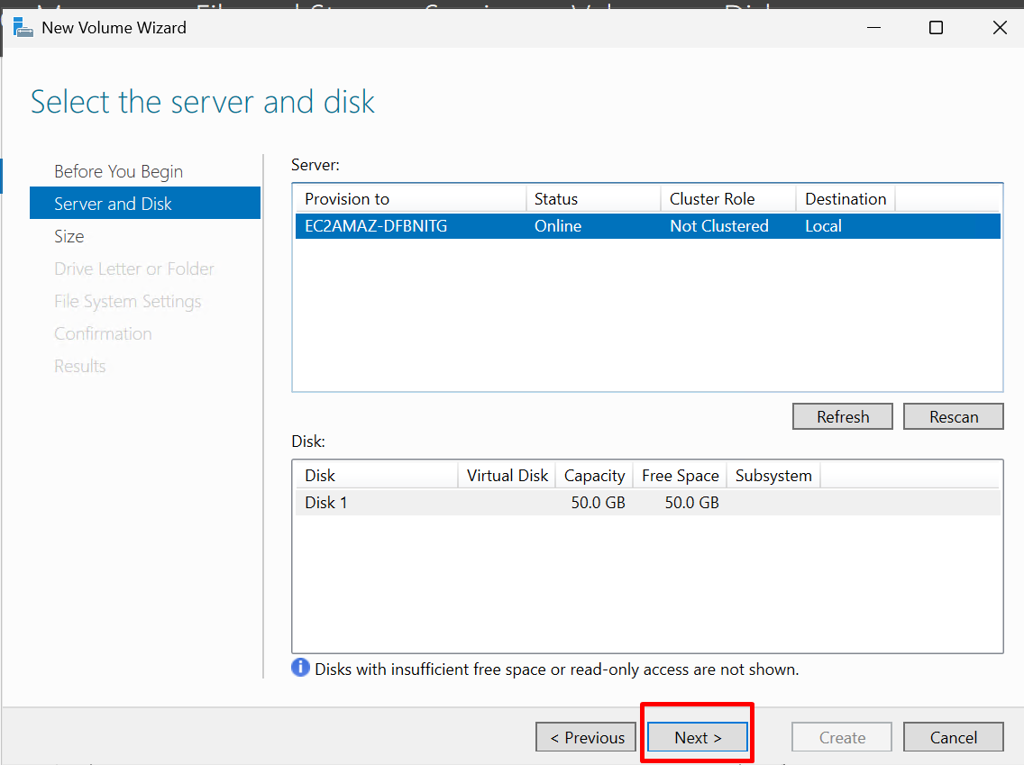

**Step7:** Specify the size of the volume

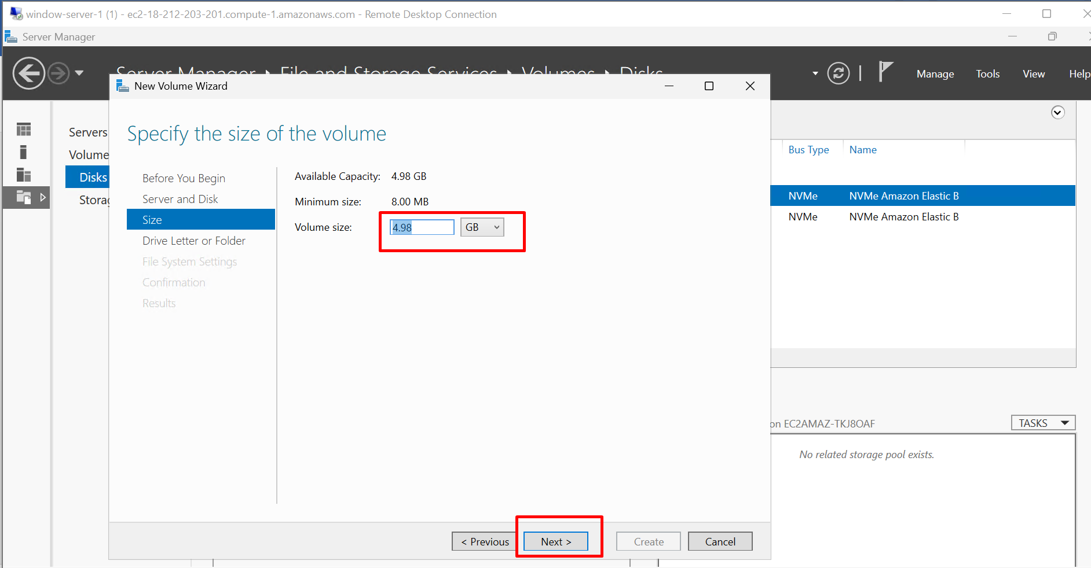

**Step8:** Assign the drive letter

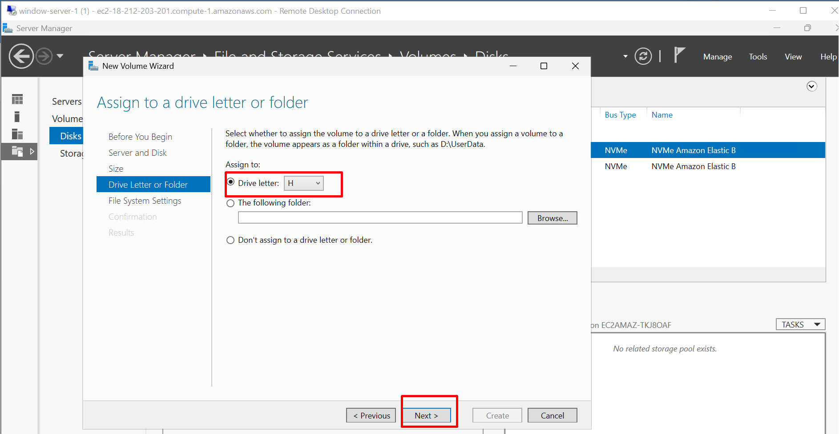

**Step9:** Select file system NTFS

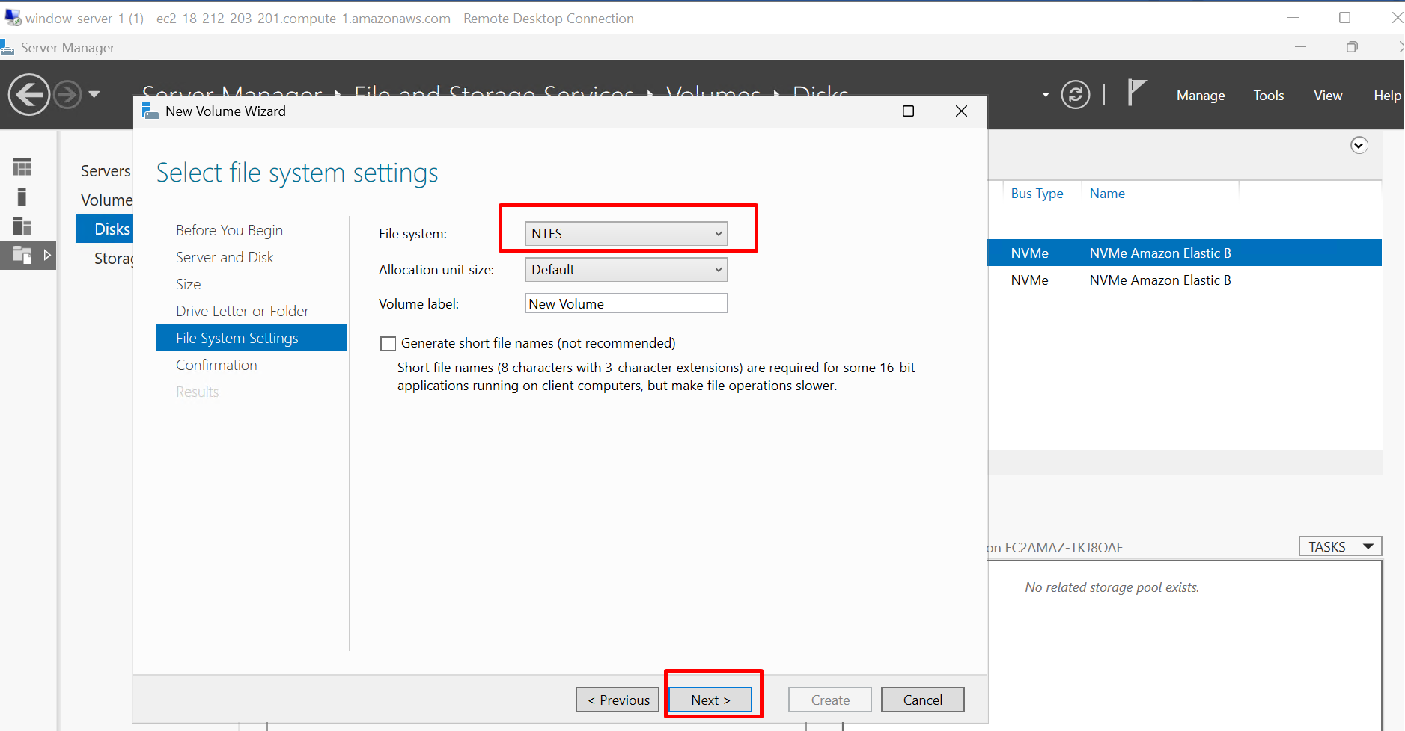

**Step10:** Confirmation of following settings

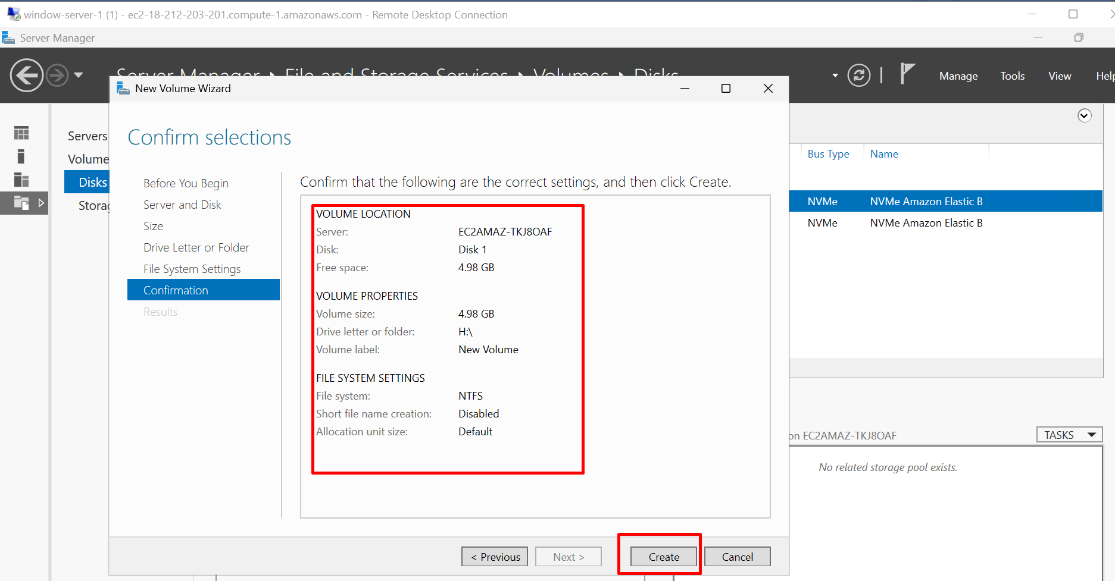

**Step11:** Now **volume** is **visible in the system**

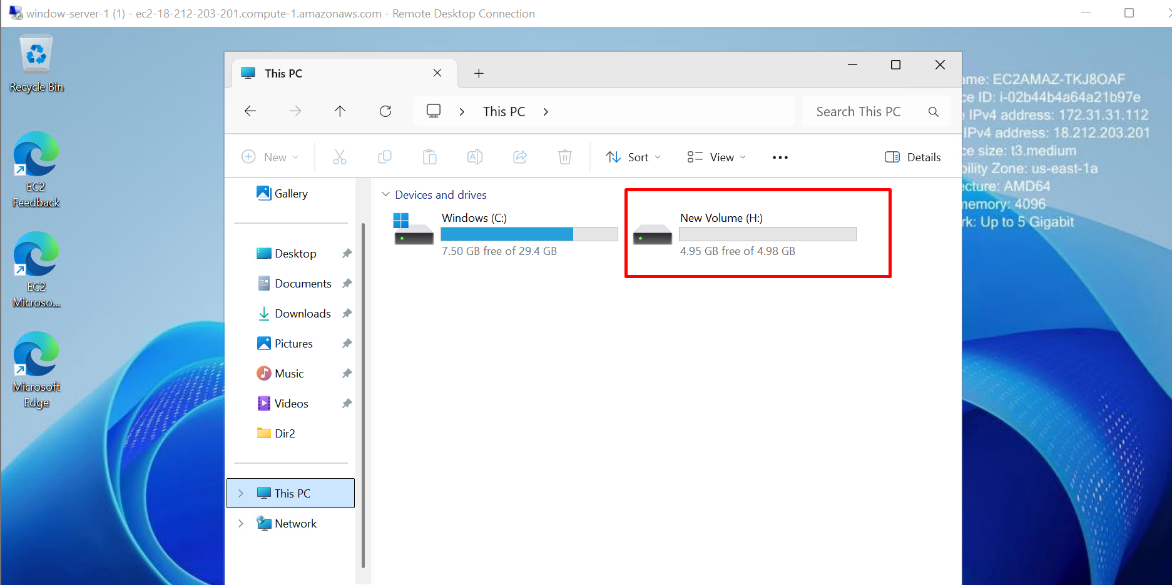

**Step12:** select actions in volume and **detach** to attach for other availability zone

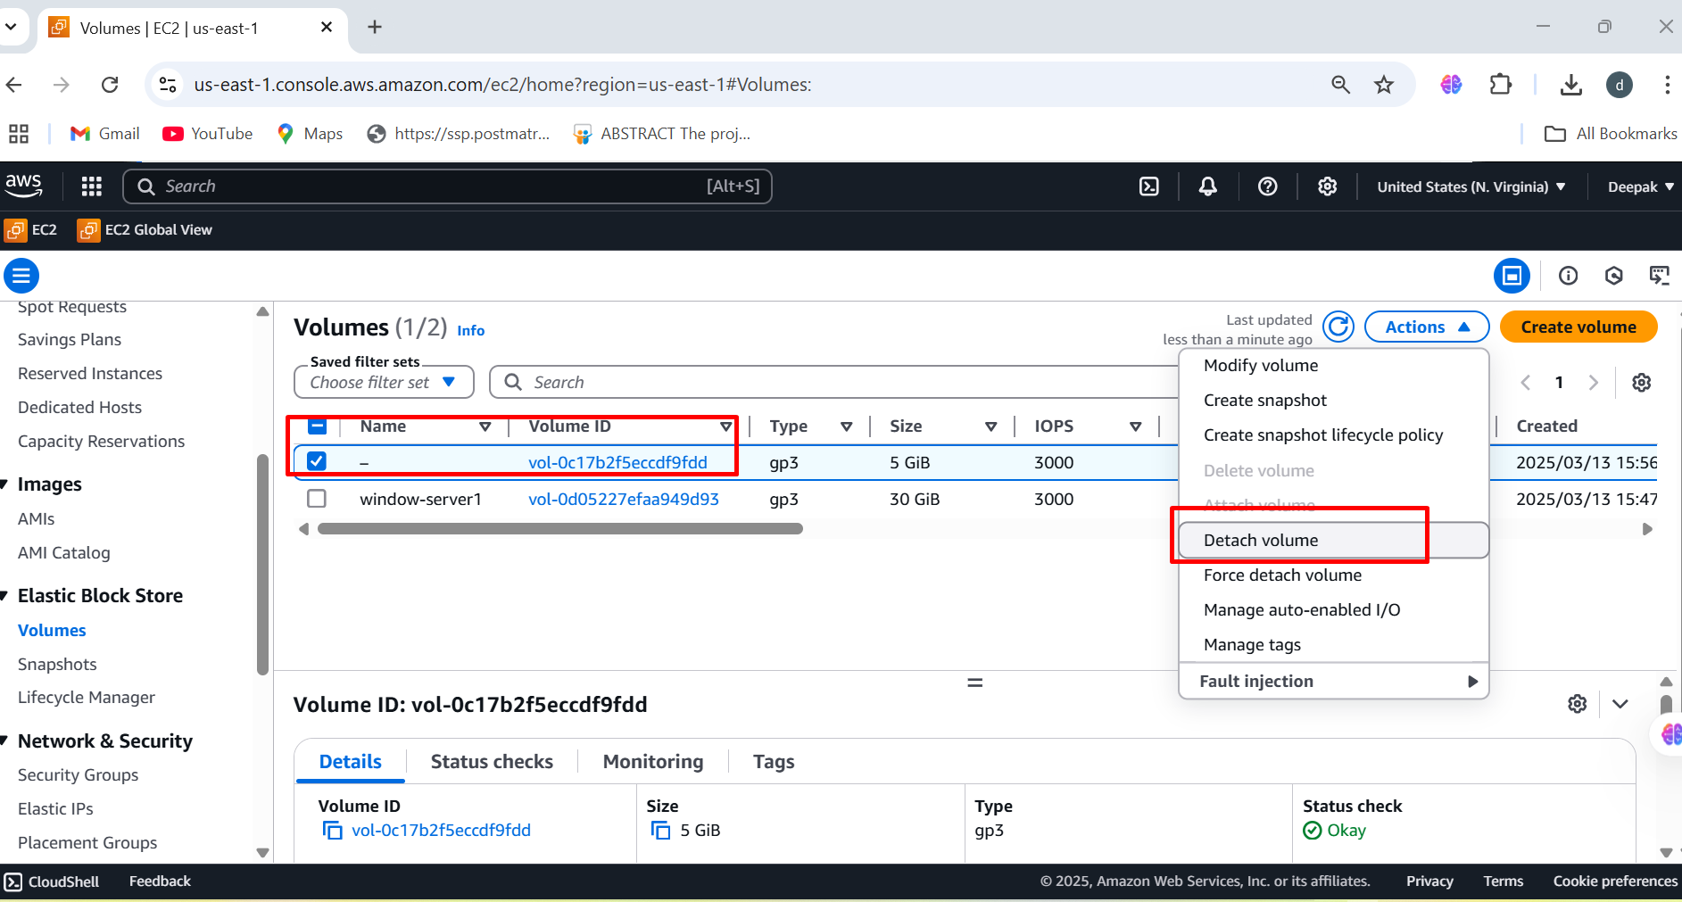

**Step13:** Volume is available not **in-use, now we can attach to other availability zone**

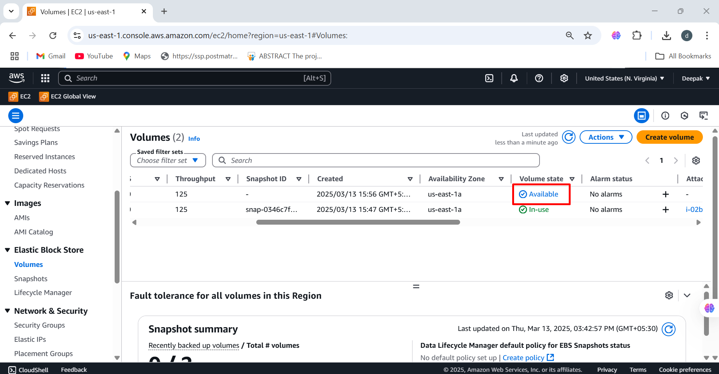

**We need to create same availability zone on window-server-2**

**Step1:** Creating same availability zone on window-server-2 (us-east-1a)

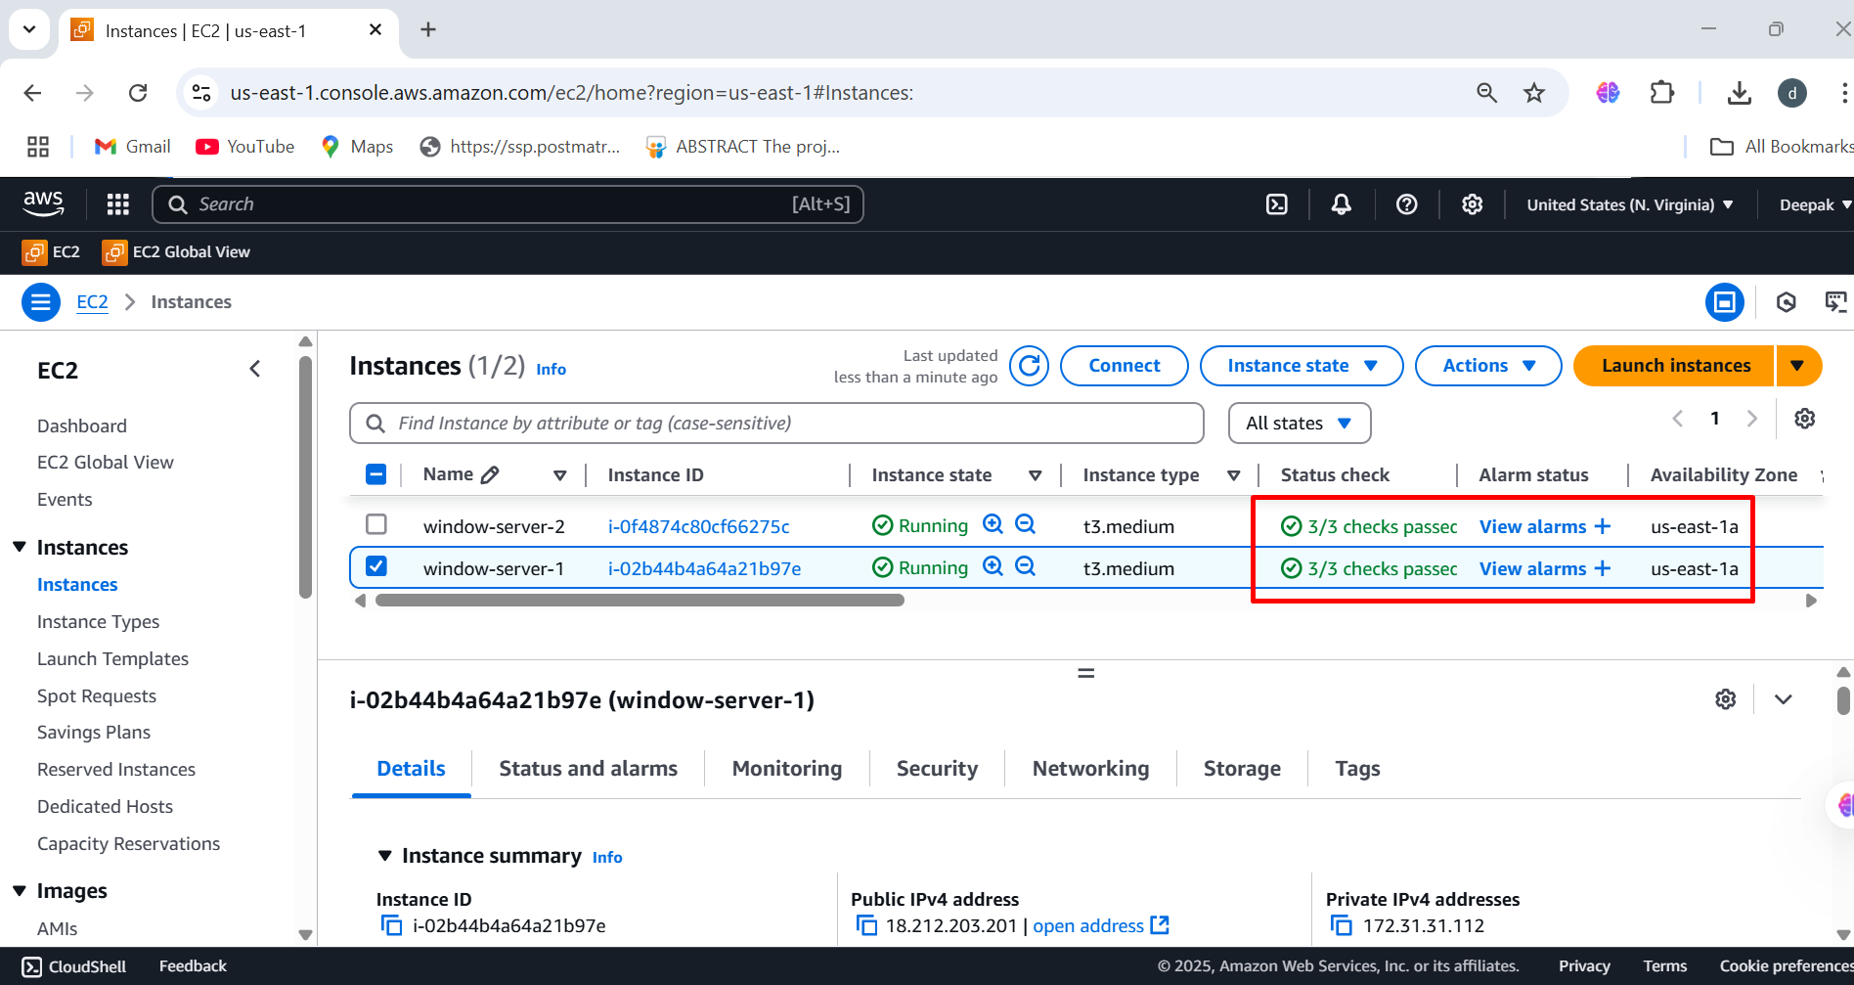

**Step2:** Creating same availability zone on window-server-2 (us-east-1a)

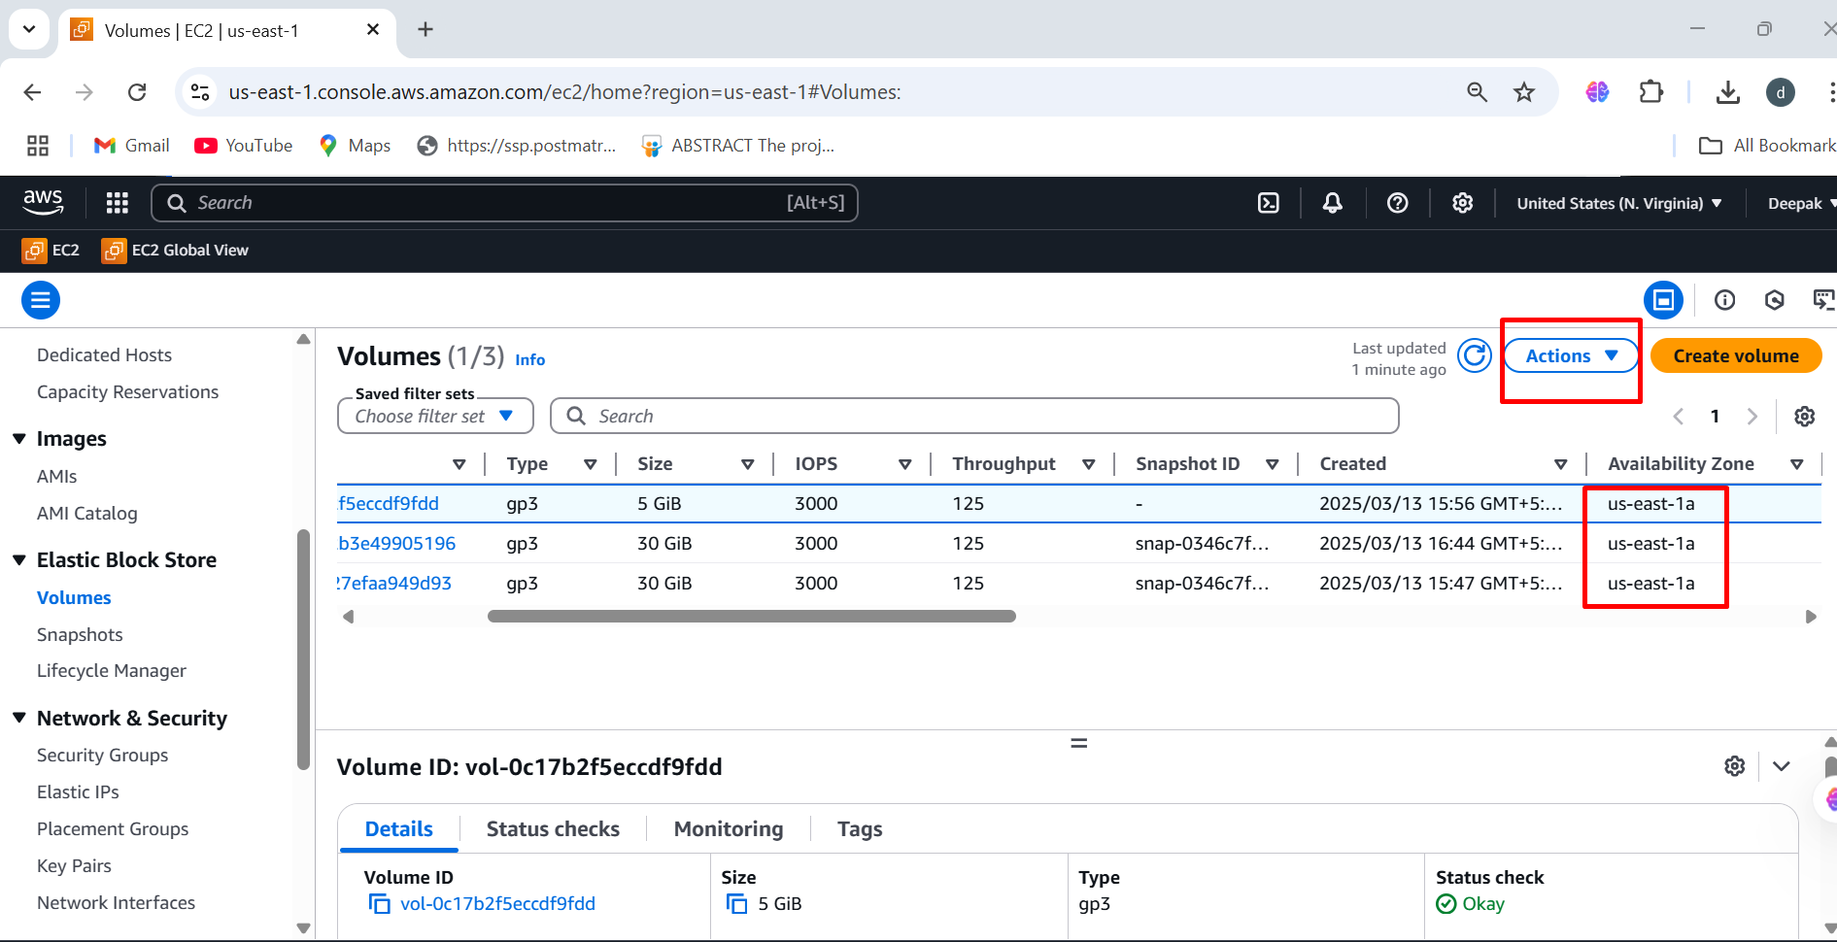

**Step3:** Attach the volume to window-server-2 (us-east-1a)

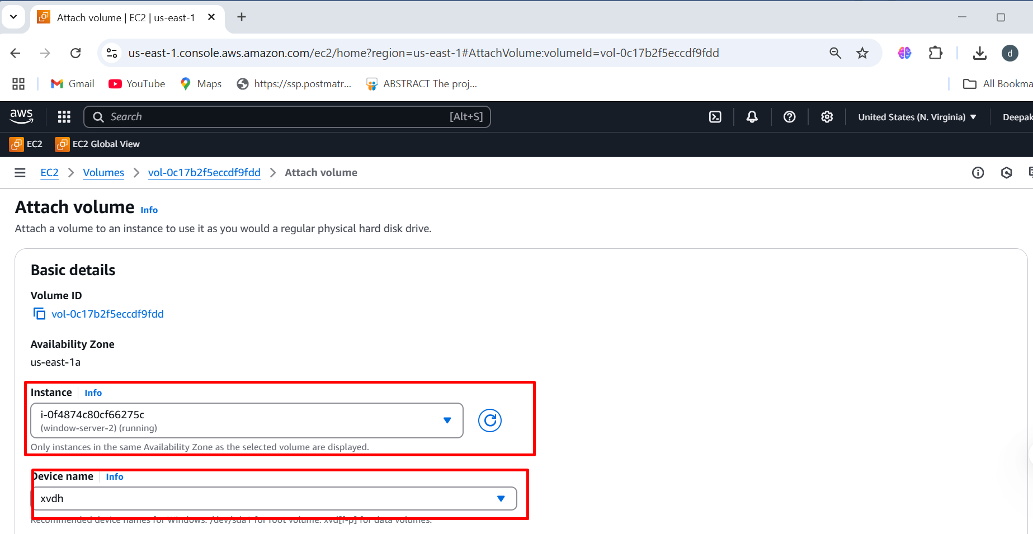

**Step4:** Click on the attach volume

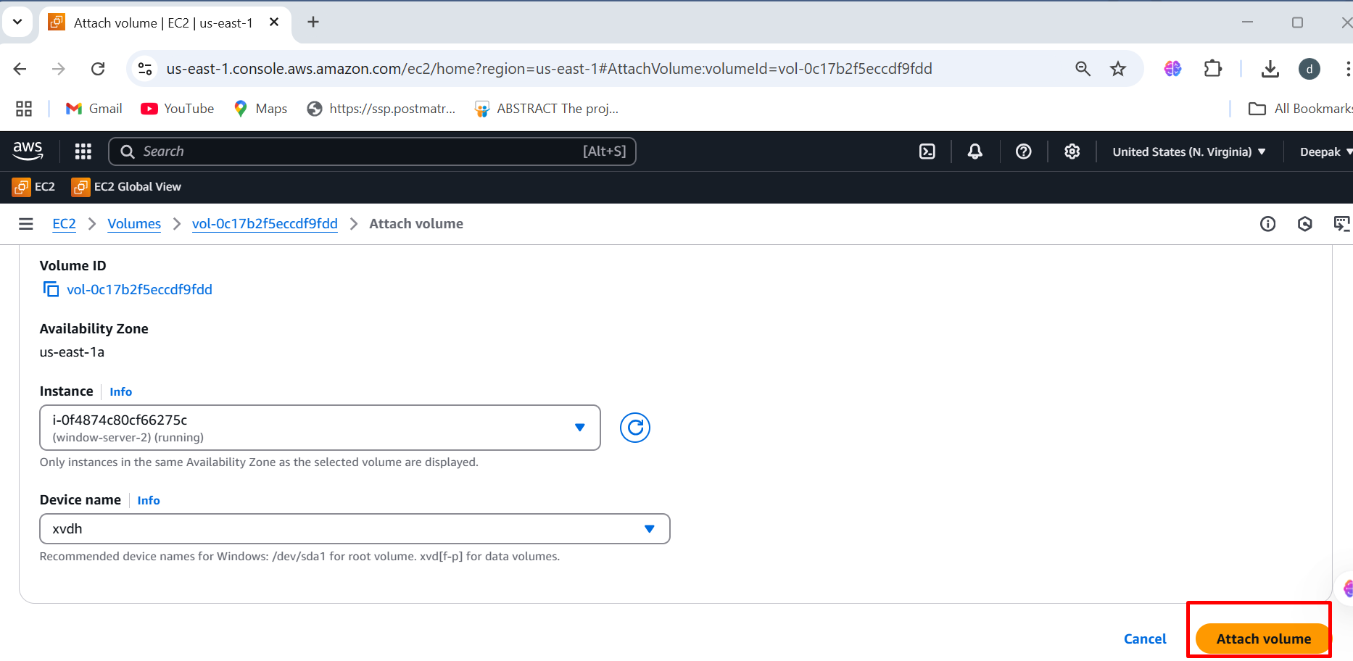

**Step5: Output of Virtual Window-Servers-2 with same availability zone**

**(us-east-1a)**

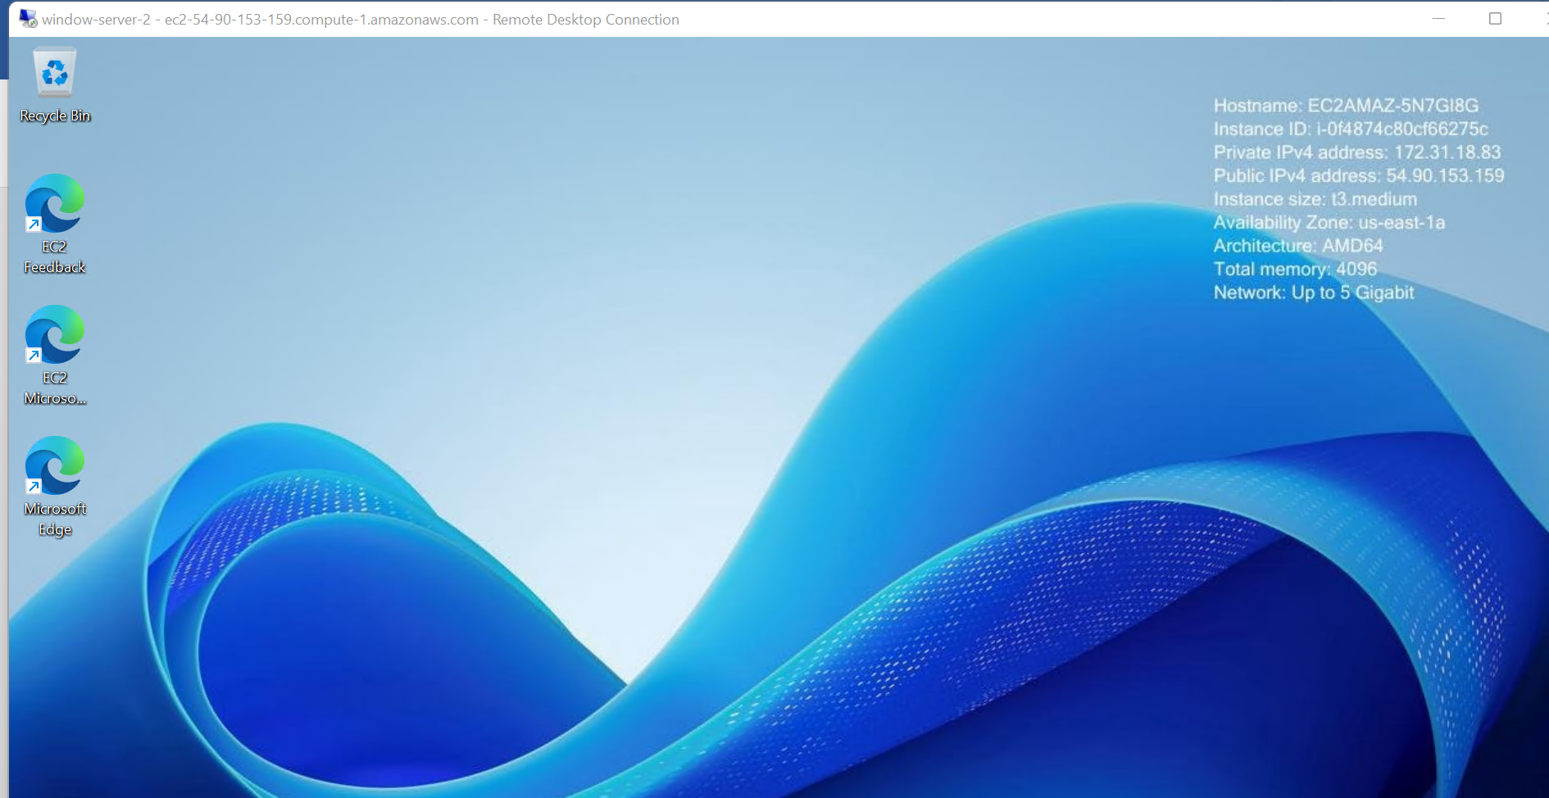

**Step6: Successfully attached an additional volume (D:) on window-server-2, and now you can access the data from window-server-1**

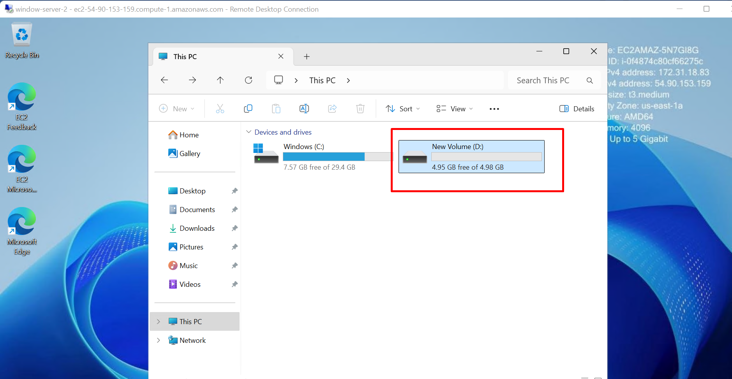

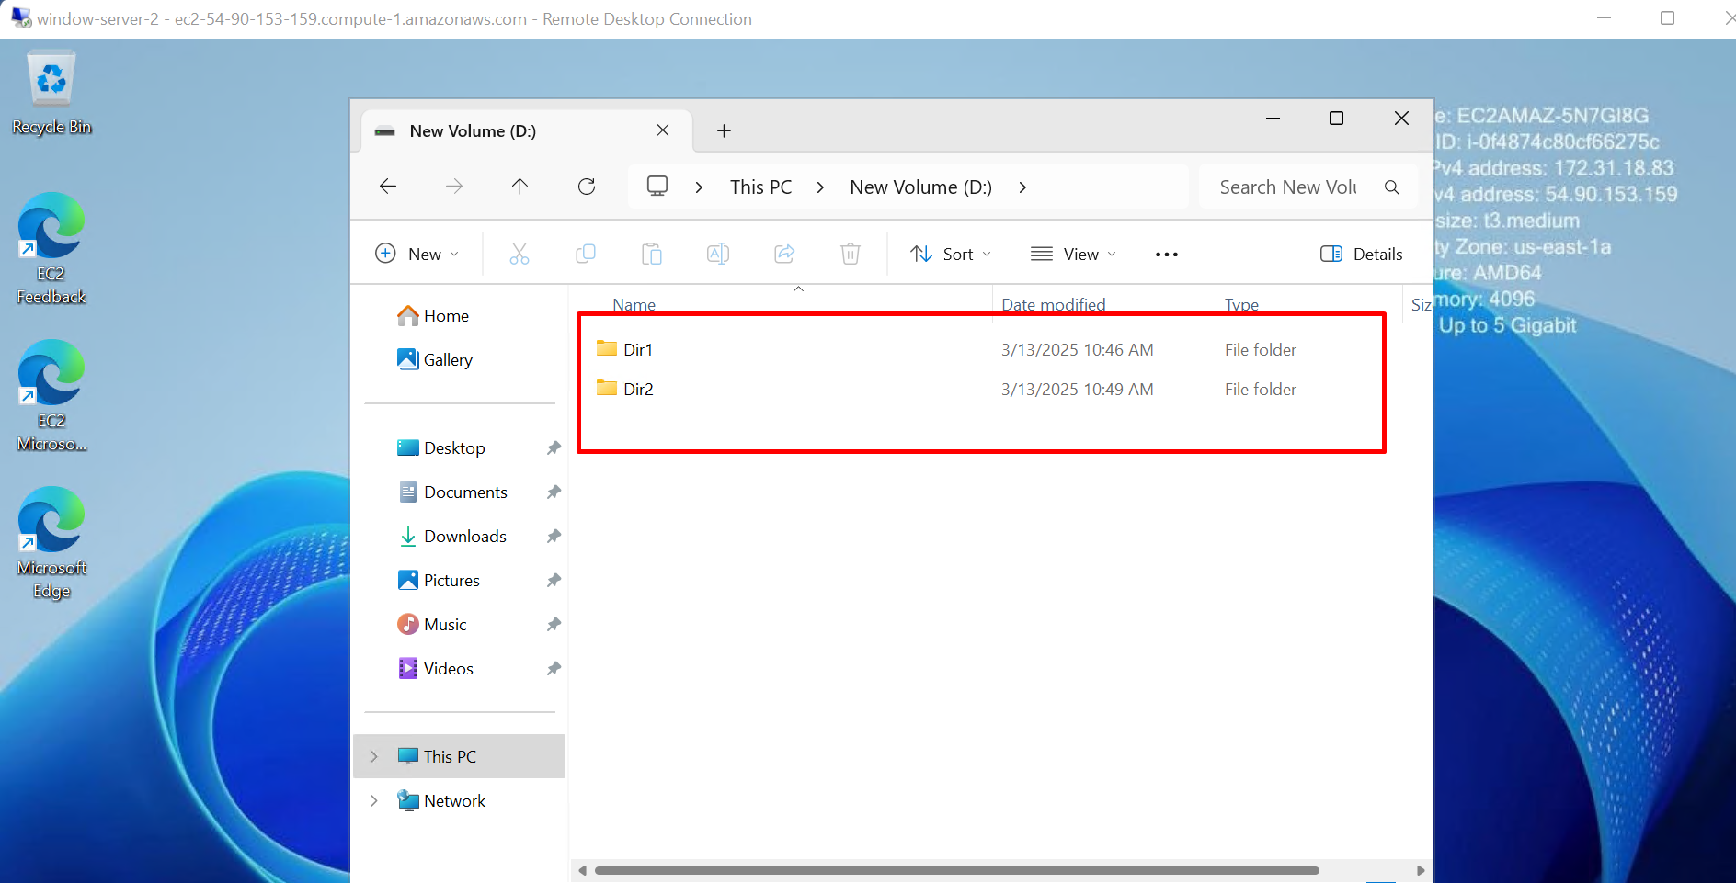

To connect an **EBS (Elastic Block Store)** volume to an **EC2 instance** **within the different availability zone**, follow these steps:

To launch Instance follow the same steps which we created in same availability zone, here need to create different availability zone

**We need to create same availability zone on window-server-3**

**Step1:** Creating different availability zone on window-server-3 (us-east-1c)

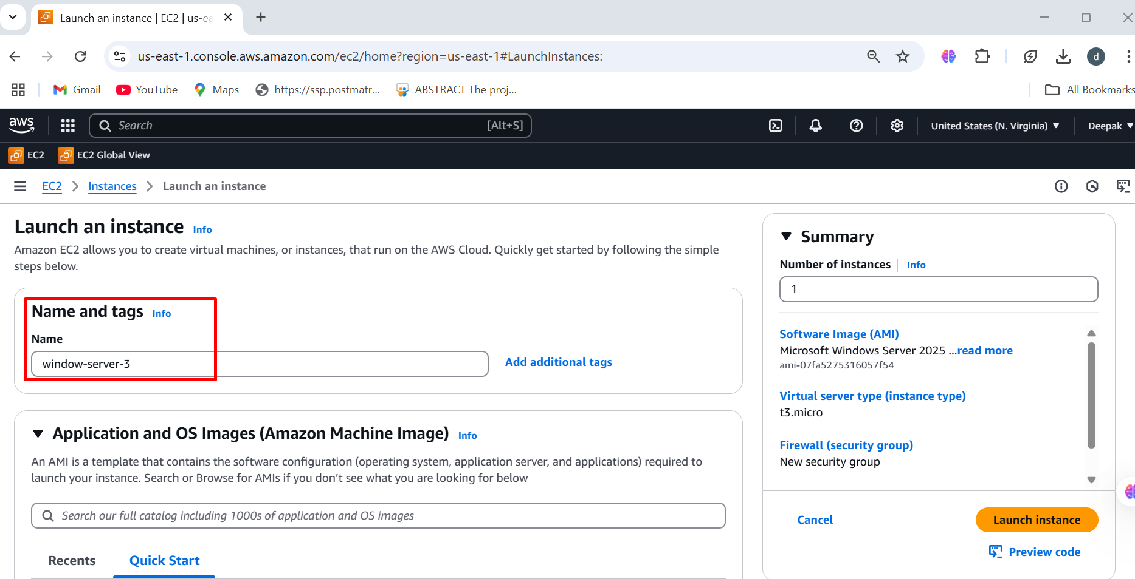

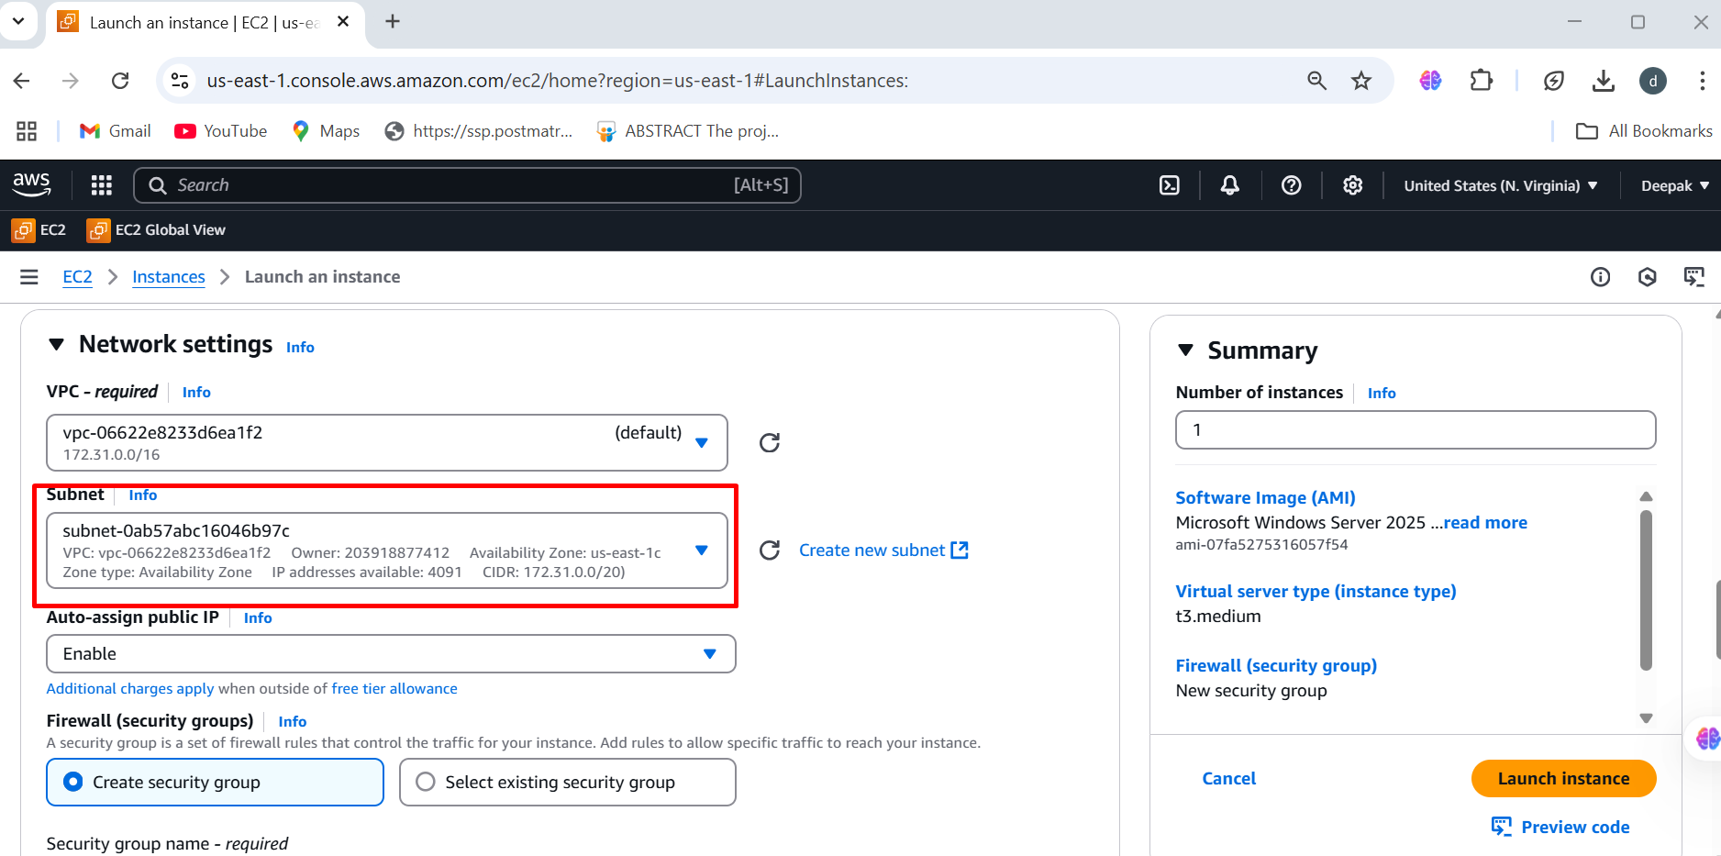

**Step3: After creating window-server-3 in (us-east-1c) check for 2/2 status**

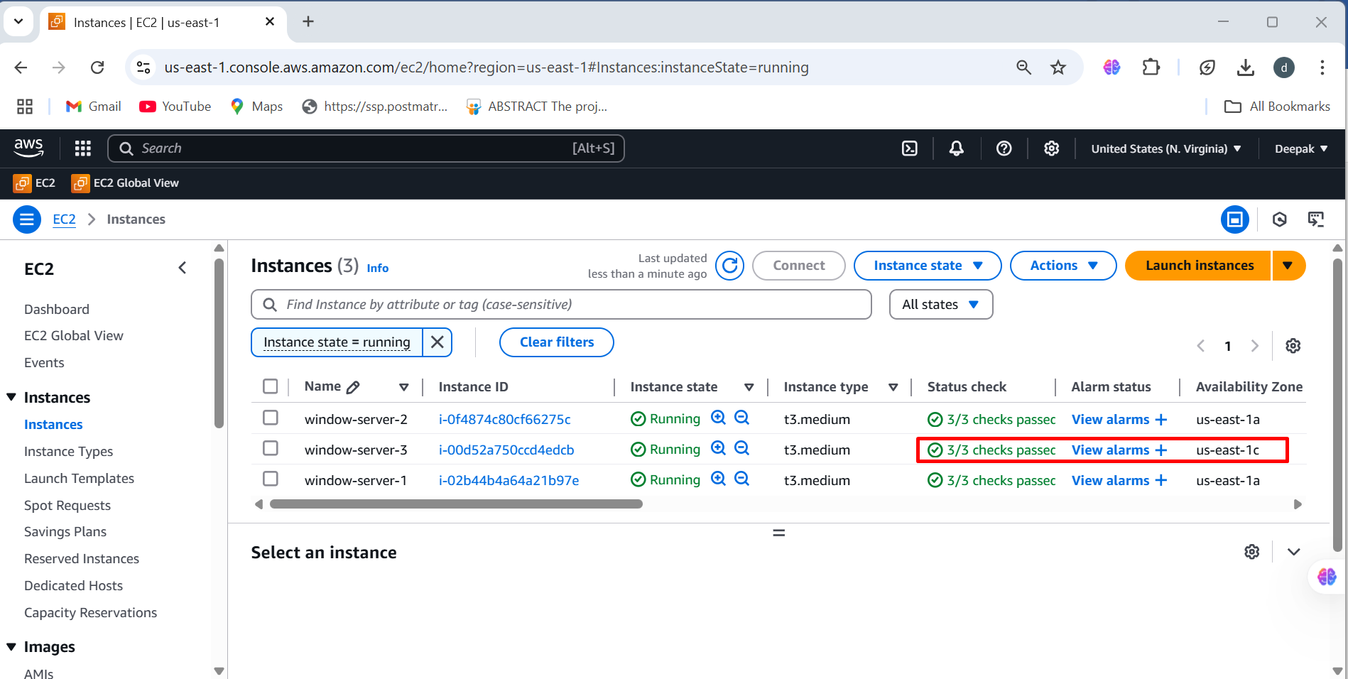

**Step4: Select the volume and detach volume which is connected by window-server-2**

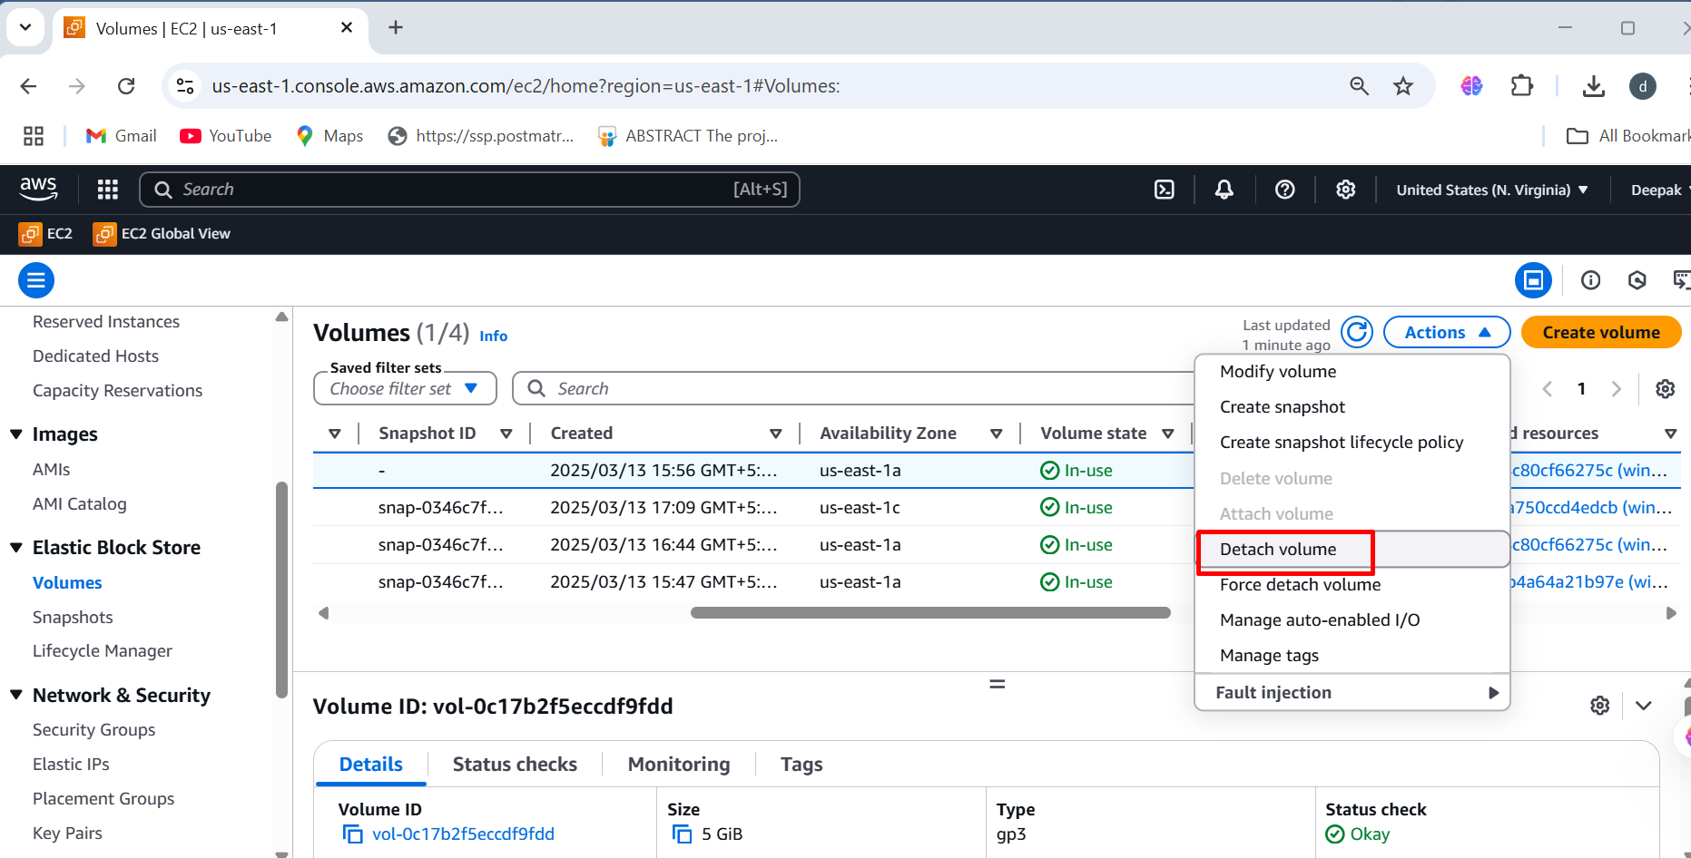

**Step5: When the volume state is available ,Then create snapshot**

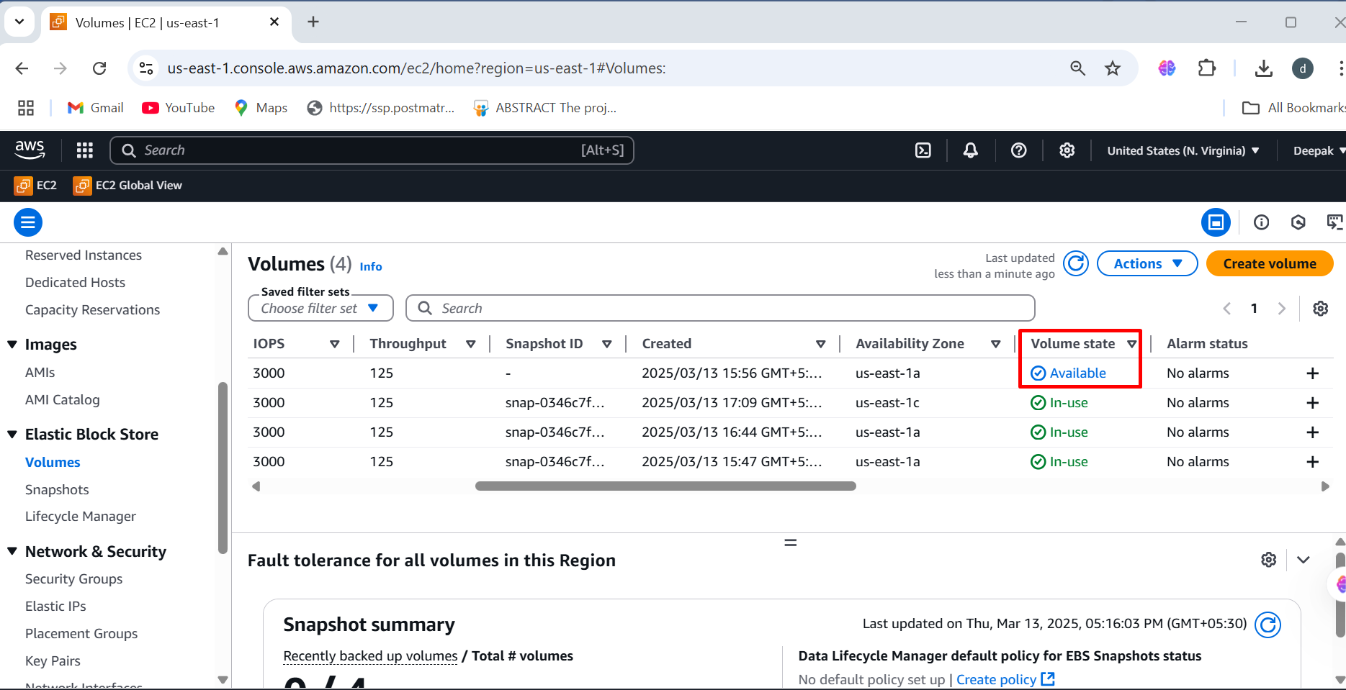

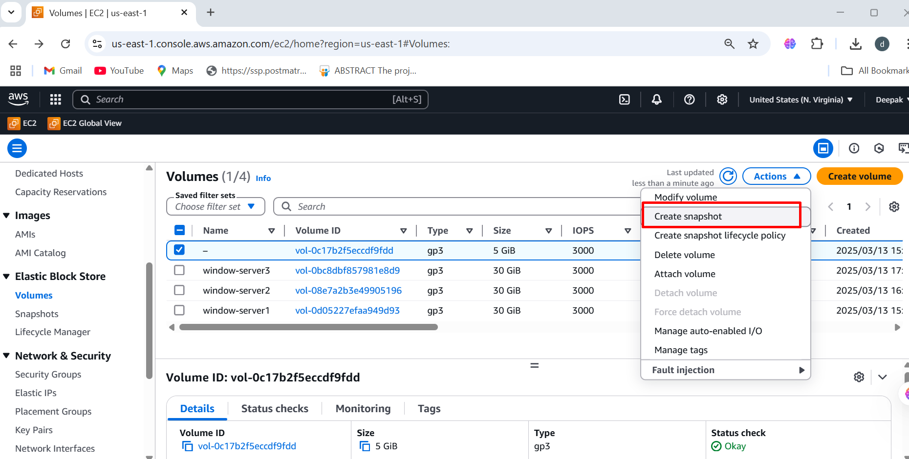

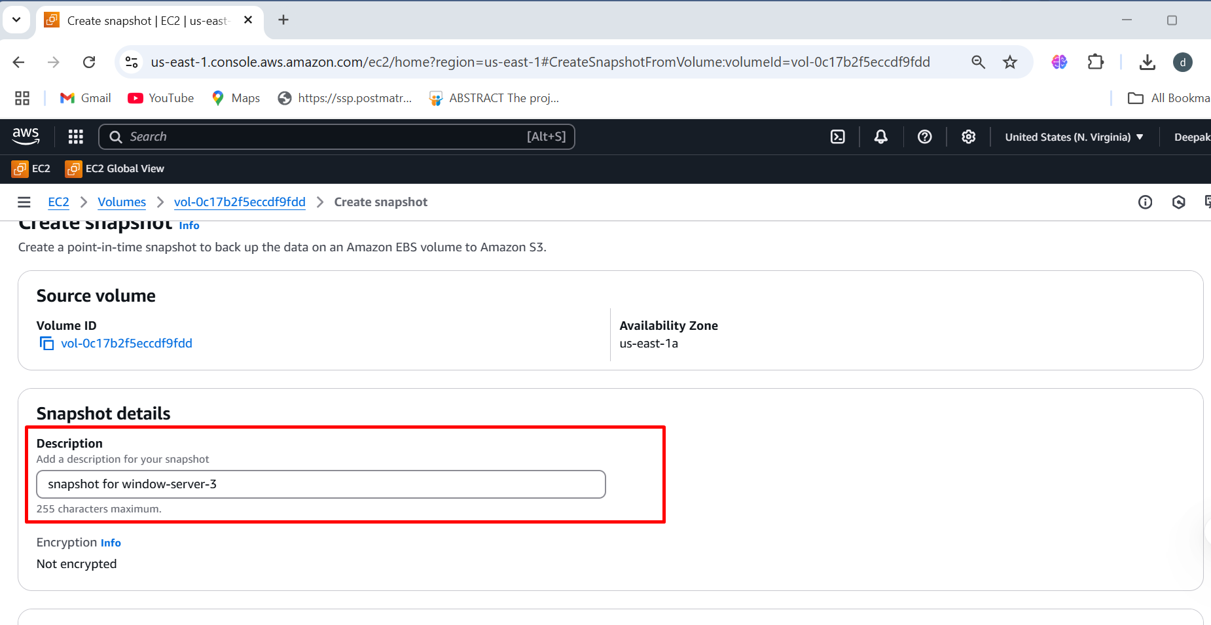

**Step6: Click on snapshot, once the status is completed, click on create**

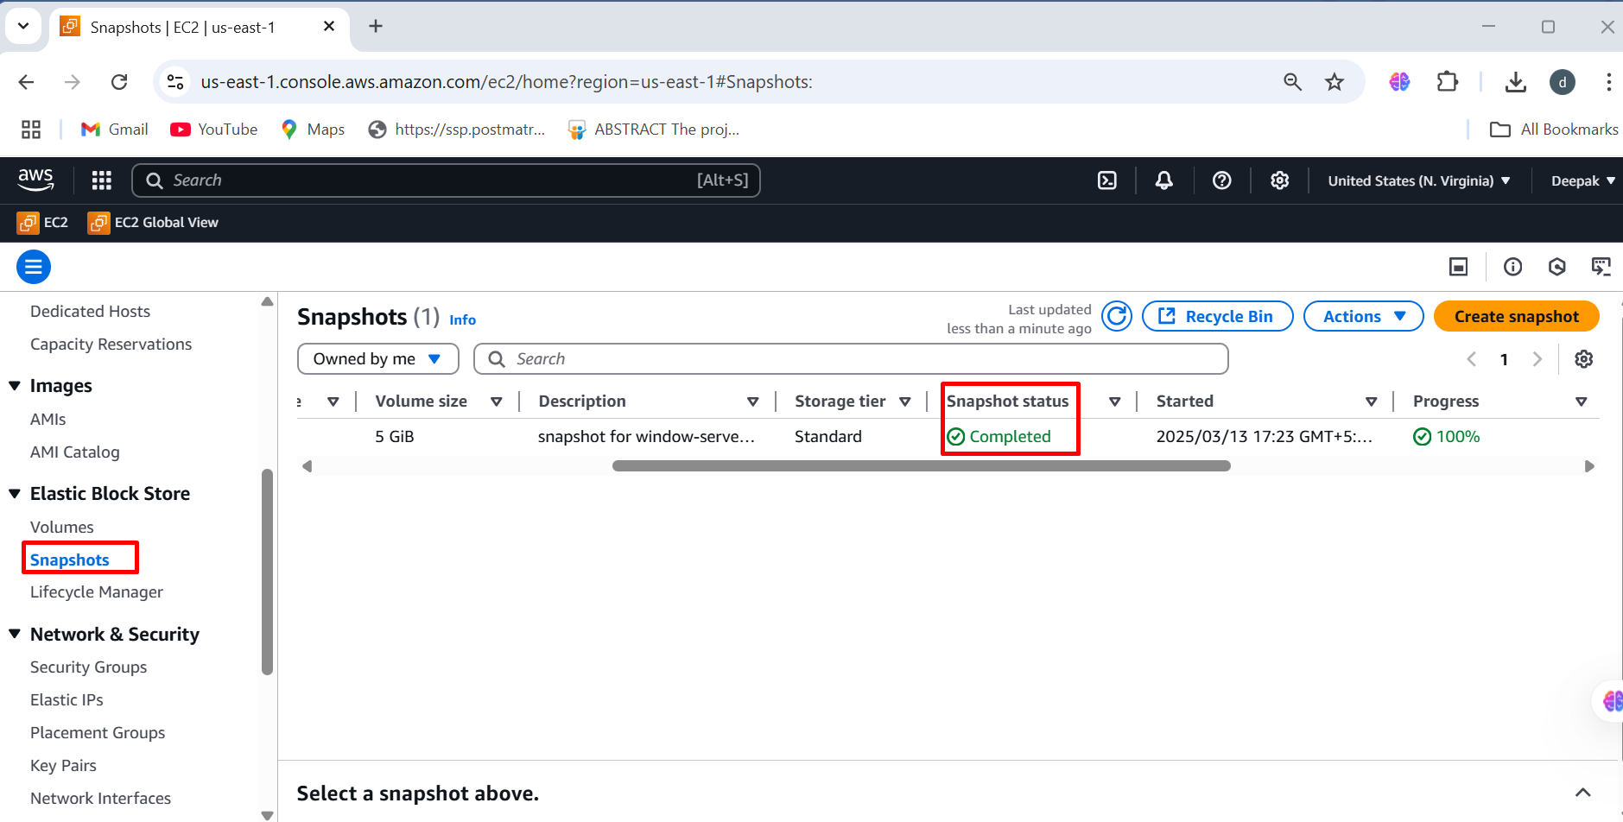

**Step7: Then Click on action 🡪 Click on create volume from snapshot**

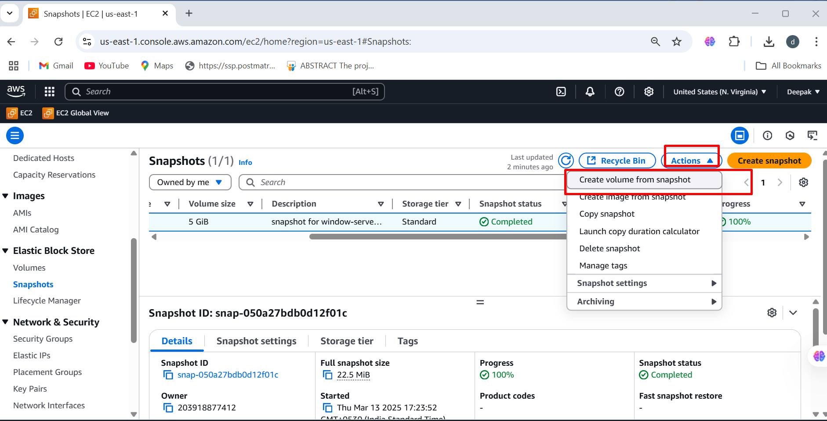

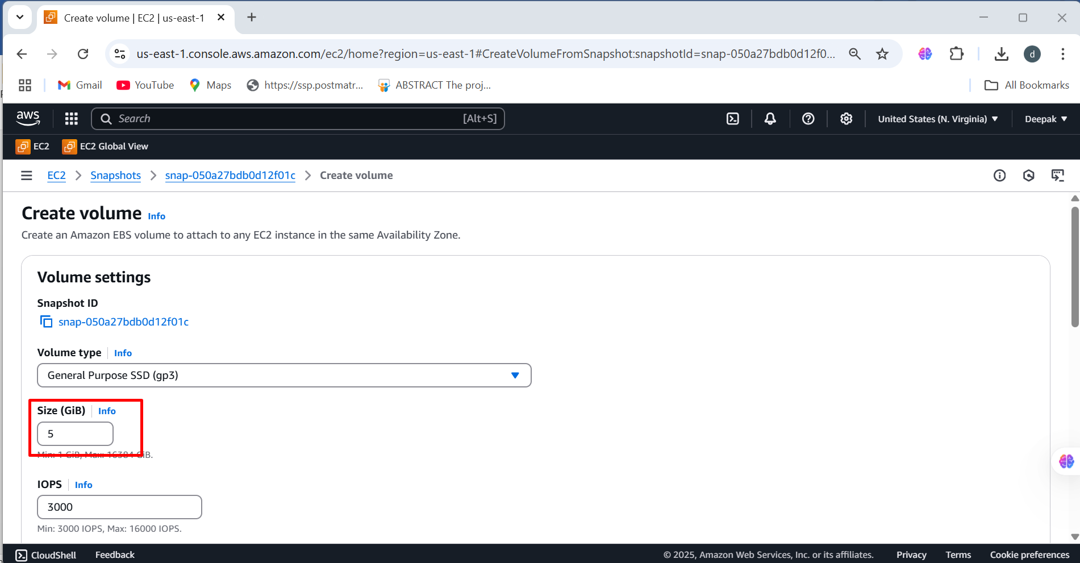

**Step8: Select the different availability zone (us-east-1c) 🡪 Create volume**

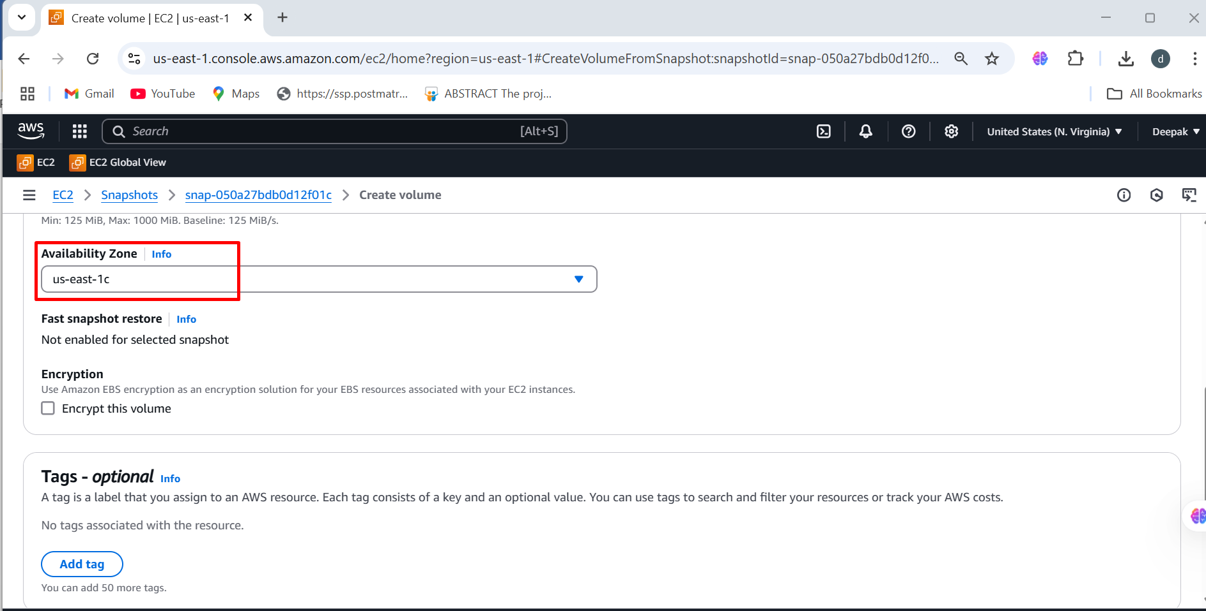

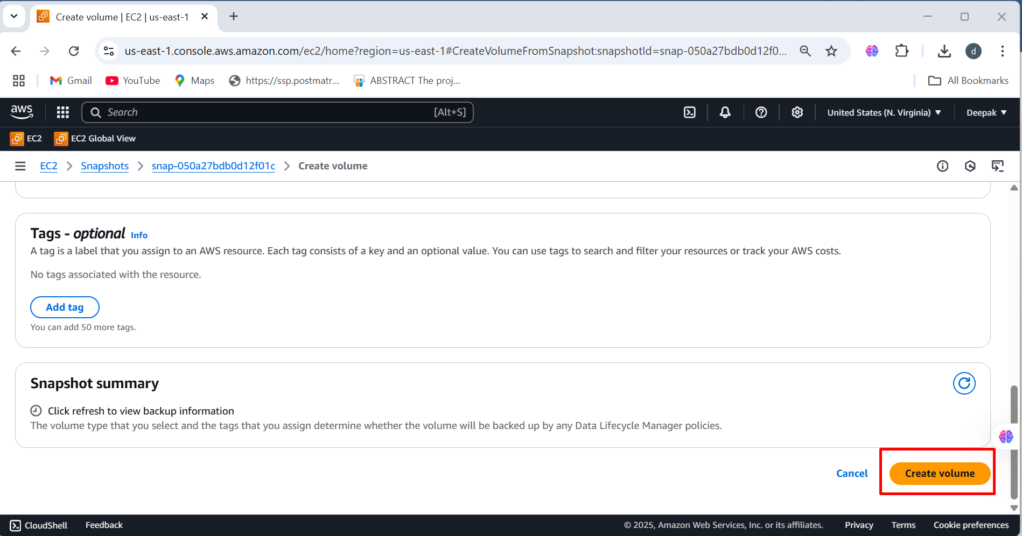

**Step9: Select the volume 🡪 once volume is available state attach the volume to window-server-3**

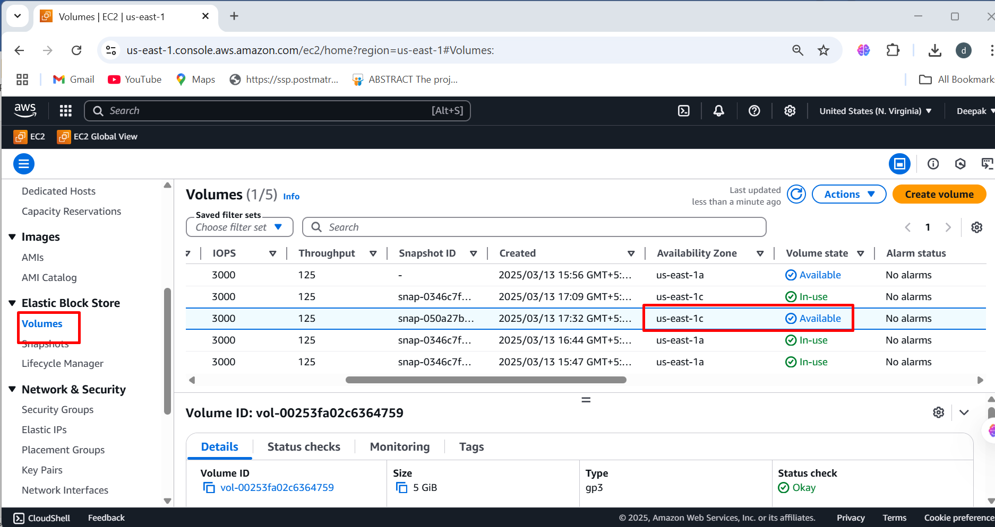

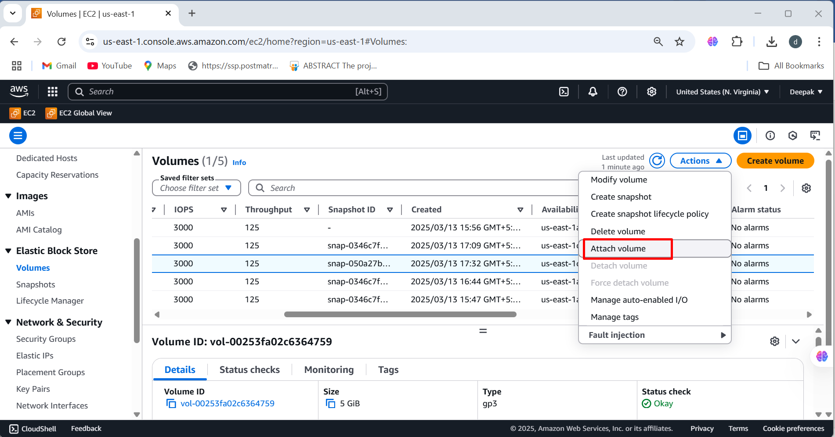

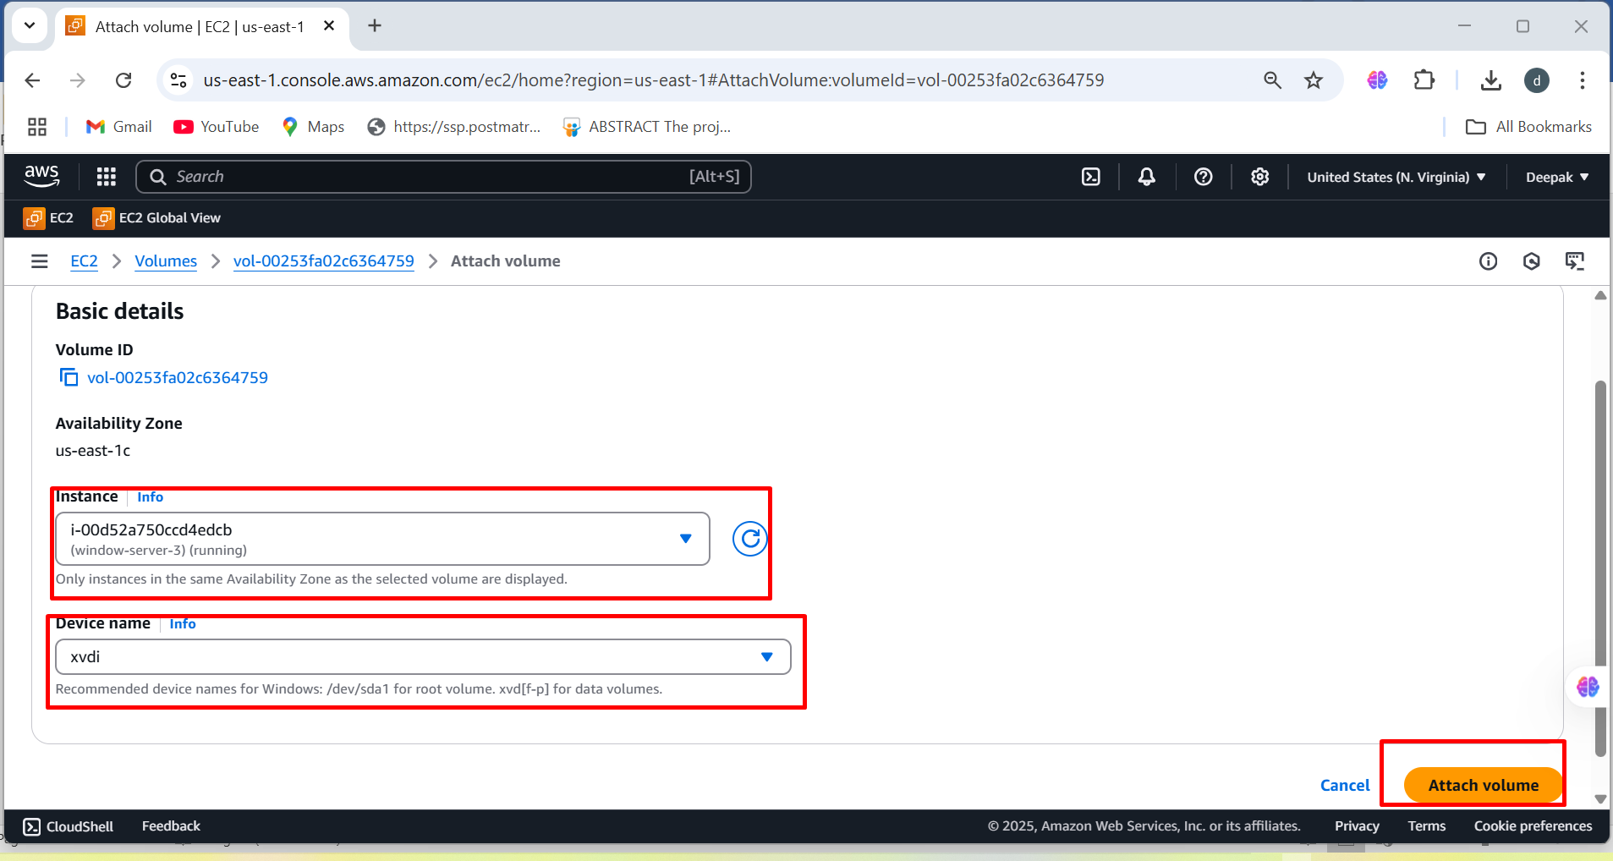

**Step10: After attaching the volume select the window-server-3 instance and** **connect to remote server**

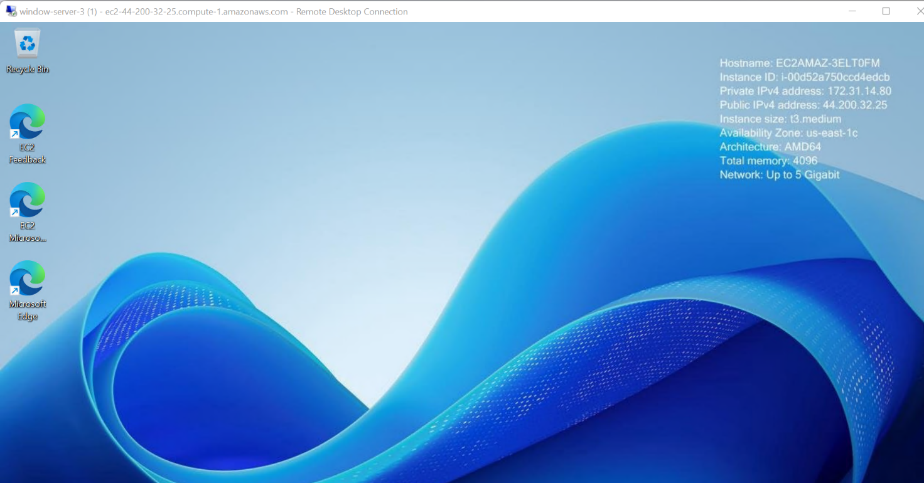

**Step11: Now we can access the data from the different availability zone**

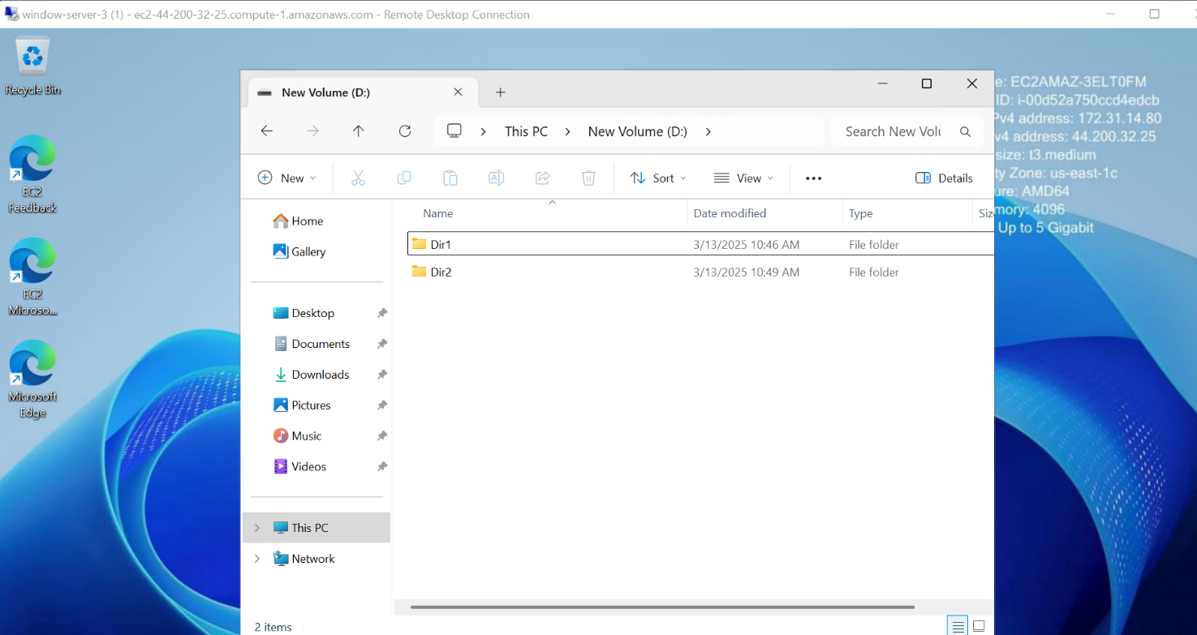

To connect an **EBS (Elastic Block Store)** volume to an **EC2 instance** **with different region**, follow these steps:

To launch Instance follow the same steps which we created in same availability zone

**Step1: We need to copy the snapshot from the window-server-3**

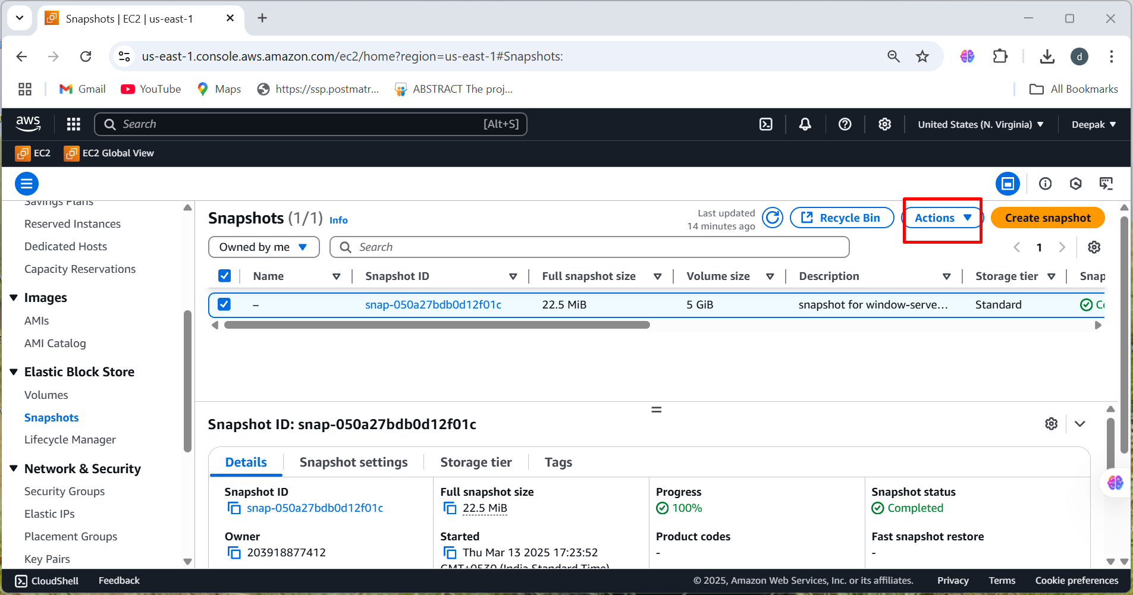

**Step2: We need to copy the snapshot from the window-server-3**

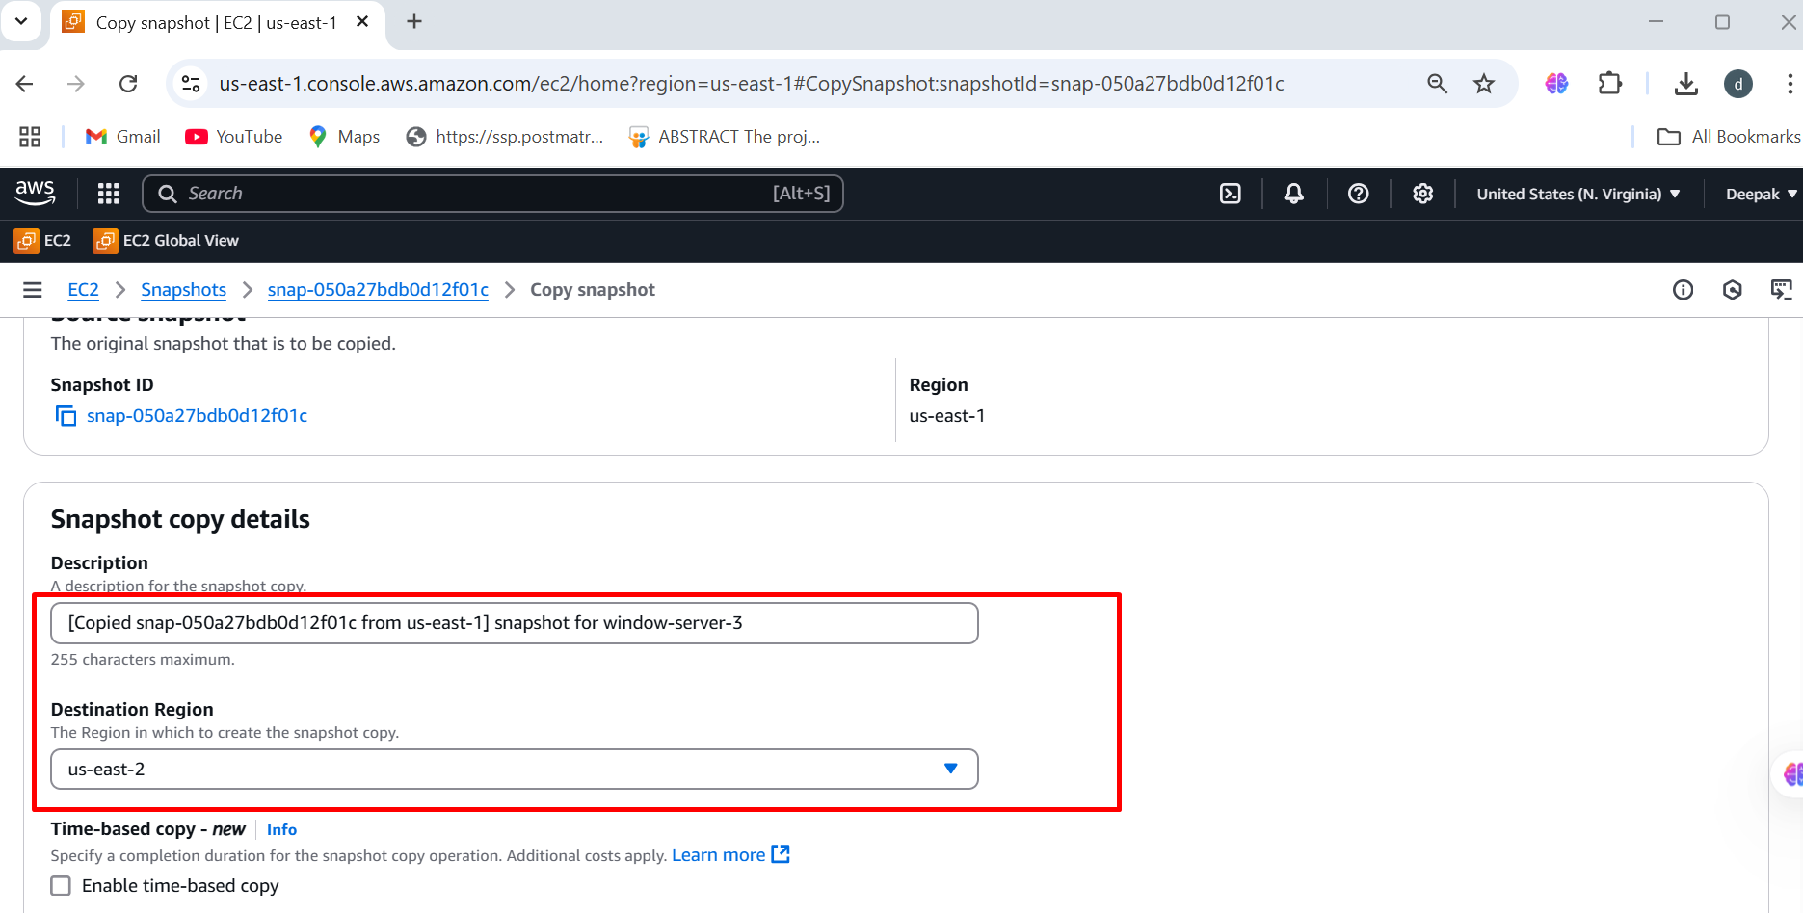

**Step3: We need to open the different region us-east-2a 🡪 it will directly display copied snapshot**

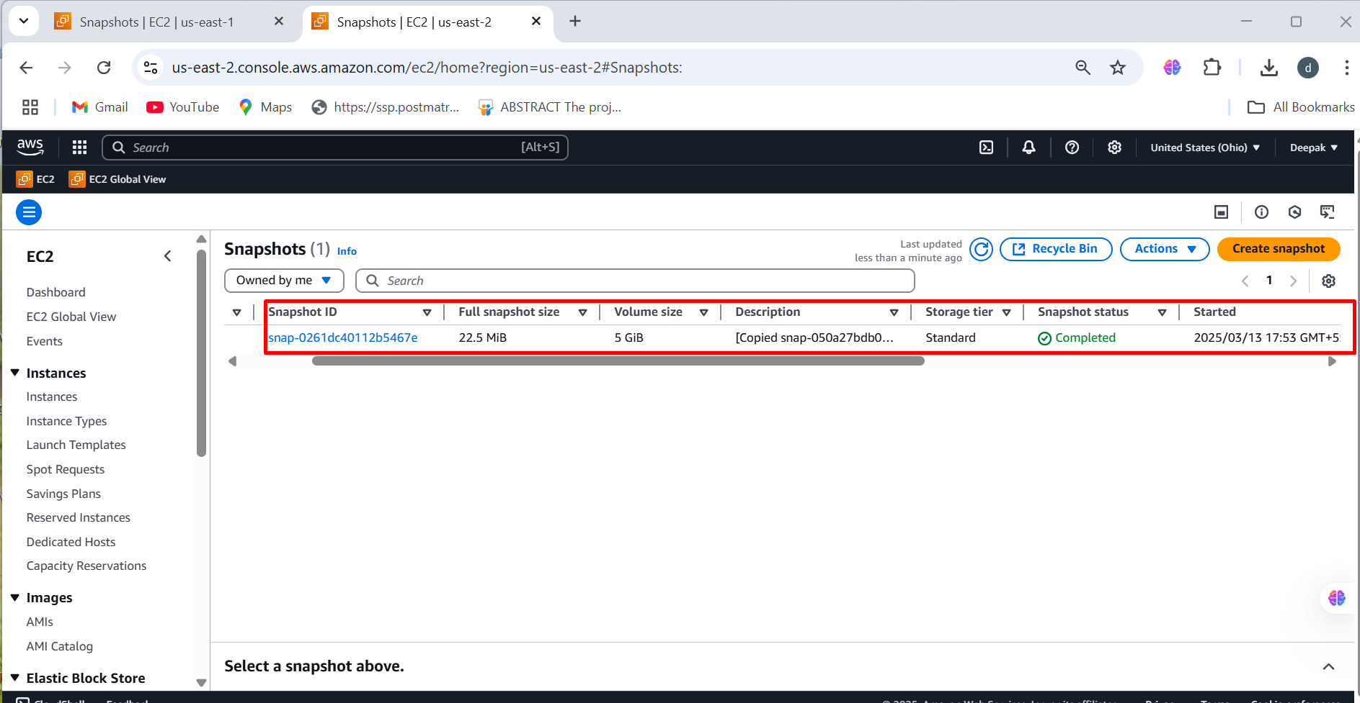

**Step4: Under the network setting we need to choose the availability zone**

**(us-east-2a)**

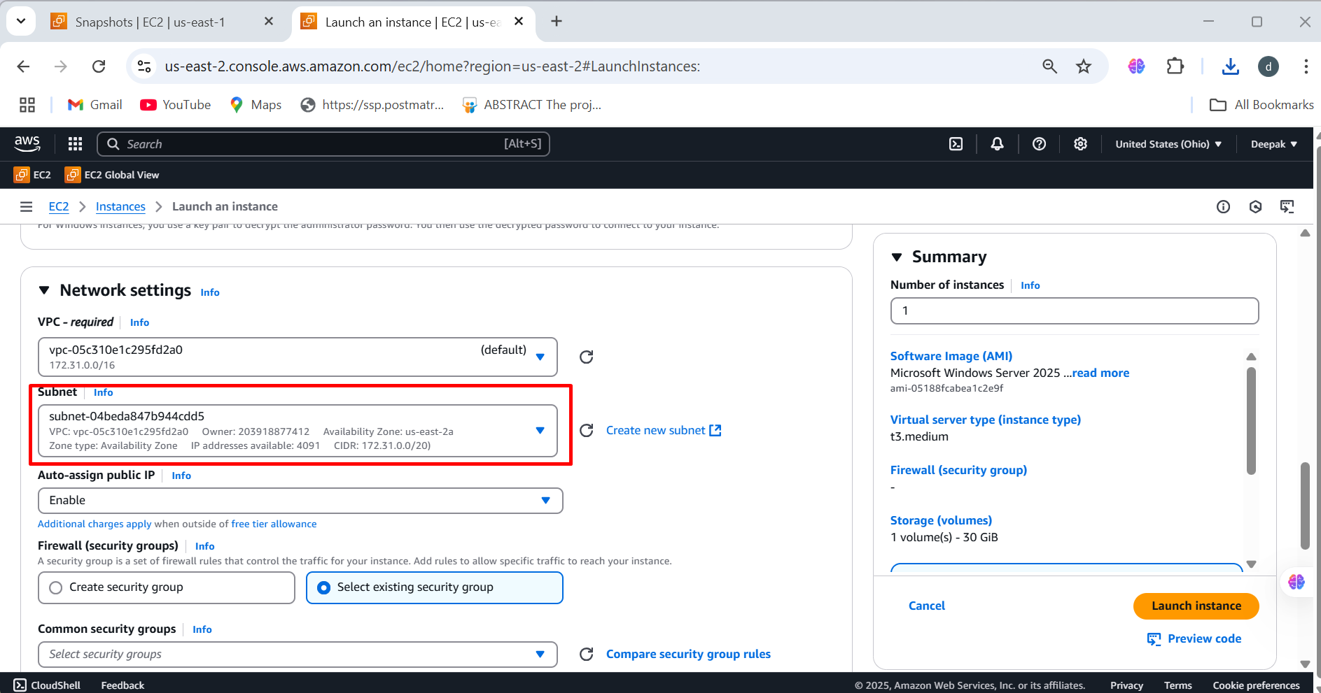

**Step5: Create volume from snapshot 🡪 Choose Availability Zone (us-east-2a) to ensure it matches the target instance 🡪Attach the Volume** to an instance in **us-east-2a** 🡪 create volume

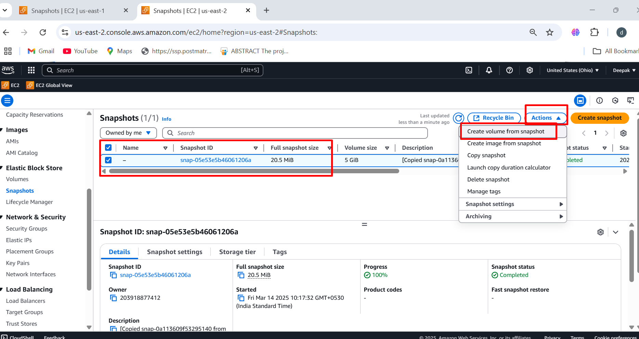

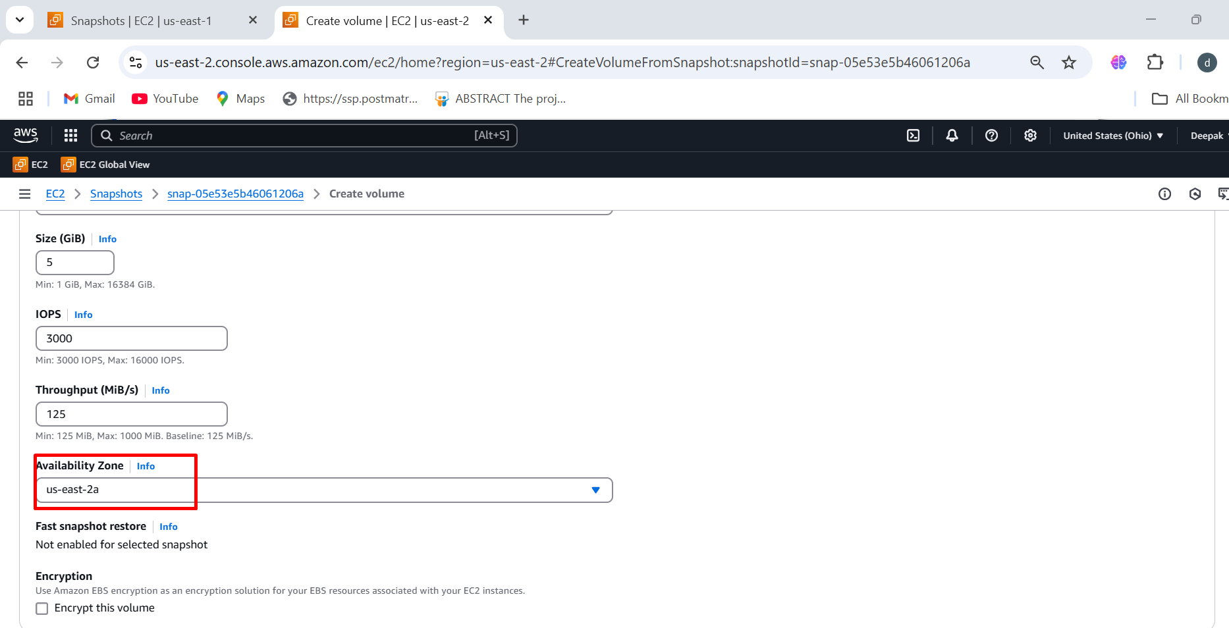

**Step6: Volumes 🡪 select the volume (us-east-2a) 🡪 action 🡪 Attach the volume 🡪 select the instance and device name 🡪 click on attach volume**

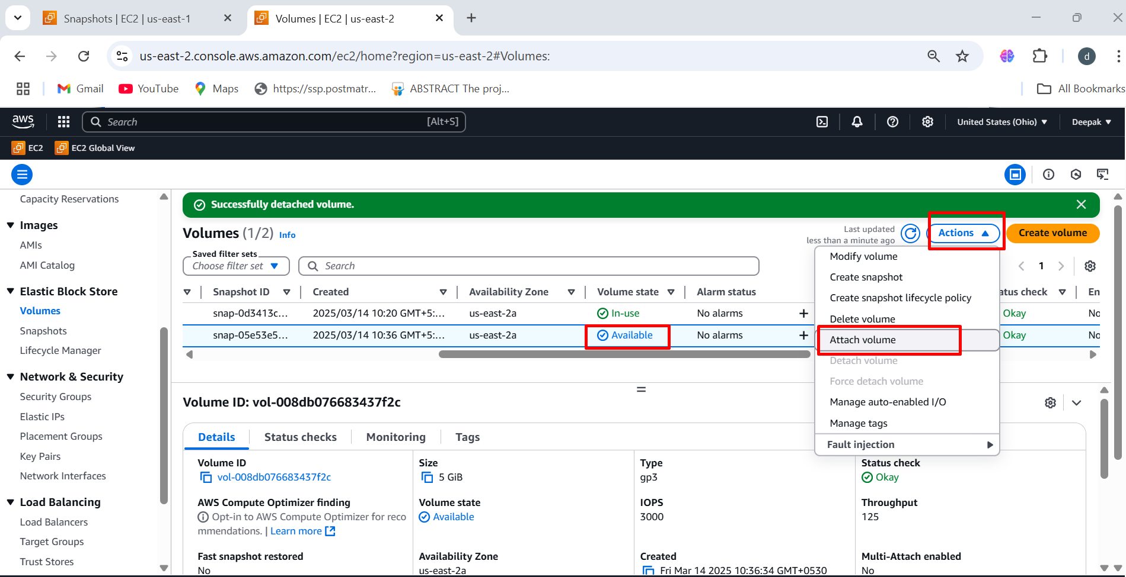

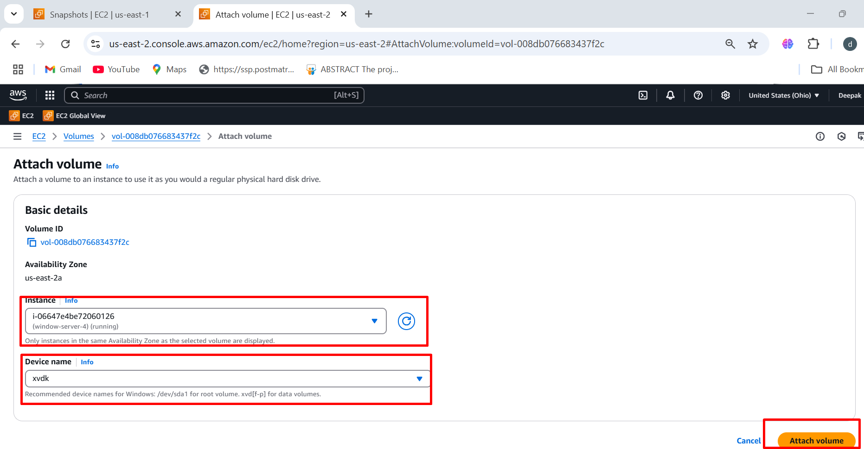

**Step7: Then launch the instance window-server-4 (us-east-2a) region 🡪 connect to remote server, now we can see the (us-east-1a) volume to (us-east-2a) region**

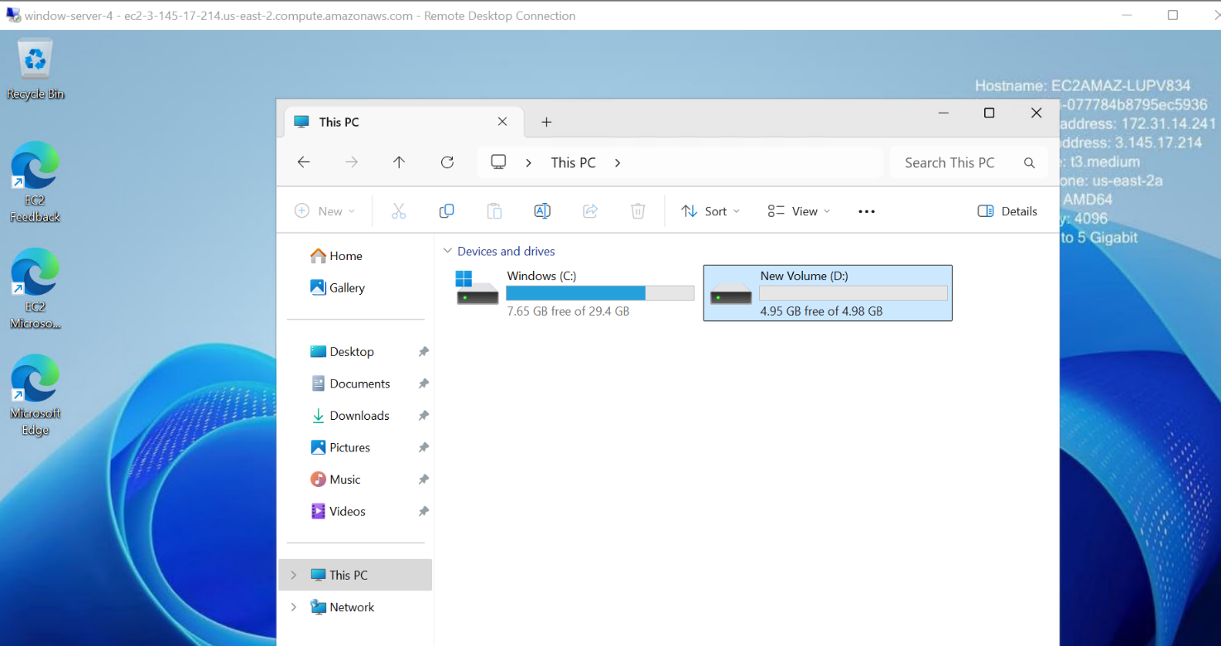

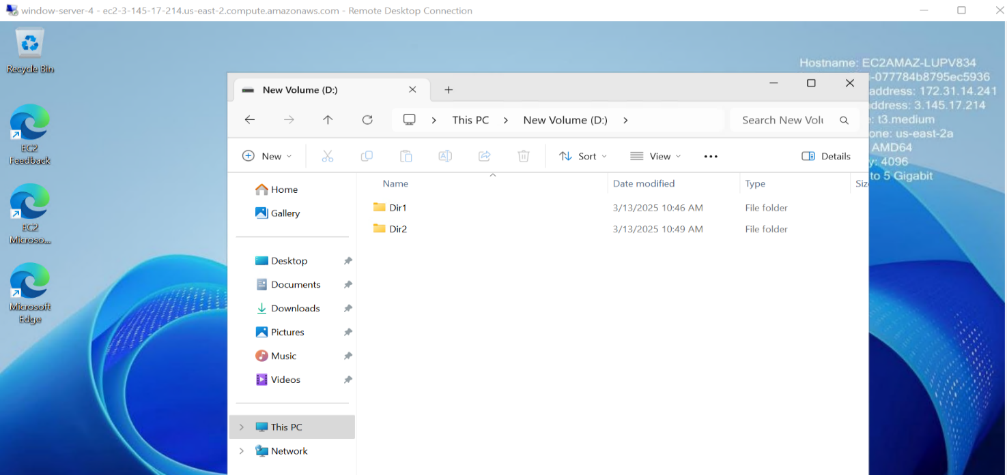

**CONCLUSION:**

This process allows you to effectively move an EBS volume between regions, ensuring that you can access and utilize the data in the new region. Just keep in mind that copying snapshots between regions incurs additional costs and may take some time depending on the size of the data.